

MSC Financial Technology & Risk Control Final Thesis

Title: Research on the Economic Value of the Blockchain Electronic Invoicing System

Student Name: Zeng Jingyu

Student ID: 2368511012

Supervisor: Iordanis Kalaitzoglou

Date:2025-05-19

**Abstract**

This study explores the effects of blockchain-based electronic invoicing systems and traditional paper invoicing systems on economic efficiency and social equity under varying audit success rates through model design and Agent-Based Modeling (ABM) computations. The results show that, under specific circumstances, the advanced system can enhance both economic efficiency and social equity.

**Keywords:** blockchain; value-added tax; ABM; simulation

Chapter Contents

Introduction 1

Literature Review 9

Methodology 21

Data Results and Analysis 23

Conclusion 47

Bibliography 48

**List of Tables and Figures**

Table 1 20

Table 2 27

Figure 1 3

Figure 2 4

Figure 3 6

Figure 4 6

Figure 5 7

Figure 6 8

Figure 7 12

Figure 8 13

Figure 9 17

Figure 10 28

Figure 11 28

Figure 12 29

Figure 13 30

Figure 14 32

Figure 15 32

Figure 16 33

Figure 17 34

Figure 18 35

Figure 19 35

Figure 20 37

Figure 21 38

Figure 22 40

Figure 23 43

Figure 24 45

**Introduction**

For a long time, tax evasion has existed to varying degrees in various countries and regions. Tax evaders save costs through tax evasion while enjoying public resources built by tax expenditures, which is unfair to law-abiding individuals and companies. How to reduce or even eliminate tax evasion has always been a key focus of tax authorities worldwide. A reduction in the tax evasion rate often increases tax revenue for tax authorities, which in turn allows governments to allocate more financial funds, enabling the construction of more social public resources and improvements in their quality, ultimately promoting social and economic development. Improved economic development can then generate more tax revenue, creating a positive cycle. Therefore, reducing tax evasion is not only conducive to enhancing social equity but also improving economic efficiency.

However, reducing the tax evasion rate requires tax authorities to improve their tax audit success rate. Enhancing the audit success rate often involves higher costs, which means a reduction in the proportion of funds originally available for public expenditure by tax authorities. This could potentially decrease funding for public construction, ultimately leading to a decline in both social equity and economic efficiency—unless the reduction in the tax evasion rate can stimulate more economic mobility and thus generate more tax revenue in the future. This study examines under what audit costs and audit success rates the tax system can have a positive impact on the economy.

**1．Basic introduction to circulation taxes**

Generally speaking, whether for income tax, value-added tax (VAT), or other types of taxes, the primary basis for tax calculation is invoices. This is because invoices serve as the original documents for accounting and the most fundamental legal basis for every transaction. Typically, invoices record details such as goods, amounts, buyers, sellers, dates, signatures, and so on. From a company’s financial statements to a tax authority’s tax revenue, invoices form the most foundational element. As a result, most methods of tax evasion involve manipulating invoices. There are generally three categories of tax evasion tactics: under-issuing or not issuing invoices at all, counterfeiting invoices, and fraudulently issuing invoices.

VAT and corporate income tax are the two tax types most closely related to invoices. Since its introduction by Maurice Lauré in 1954, VAT has been adopted by various countries for its innovativeness, fairness, and efficiency. Unlike traditional sales taxes, VAT is levied based on the value added at each stage of production and distribution of goods or services, rather than being collected in a single lump sum at the final sales stage.[1] Corporate income tax, on the other hand, is levied on a company’s profits, with the tax calculation also primarily based on invoices. Taking China’s invoices as an example, they are mainly divided into special invoices and ordinary invoices. The former can be used as input tax credits for VAT, while the latter cannot. Both can serve as the basis for income tax calculation.

VAT and income tax have long been the main components of China’s tax revenue, which in turn constitutes the majority of China’s fiscal revenue. In other words, China’s fiscal revenue primarily originates from VAT and income tax. In 2024, China’s general public budget revenue reached $2,197.02 billion, with tax revenue amounting to $1,749.72 billion, accounting for 79.64%. Domestic VAT (excluding imports) was $666.72 billion, making up 38.10% of tax revenue, while corporate income tax was $408.87 billion, accounting for 23.37%[2]. Additionally, VAT and income tax are the most common types of taxes targeted by tax evaders.

Ordinarily, when a supplier sells goods to a retailer, it issues an invoice to the latter. The VAT amount recorded on the invoice represents the output tax for the supplier and the input tax for the retailer. When the retailer sells goods to consumers, it must also issue an invoice, with the tax amount on the invoice becoming the retailer’s output tax. The VAT payable to the tax authority is calculated by subtracting the input tax from the output tax. The following diagram illustrates the calculation methods for VAT and income tax.

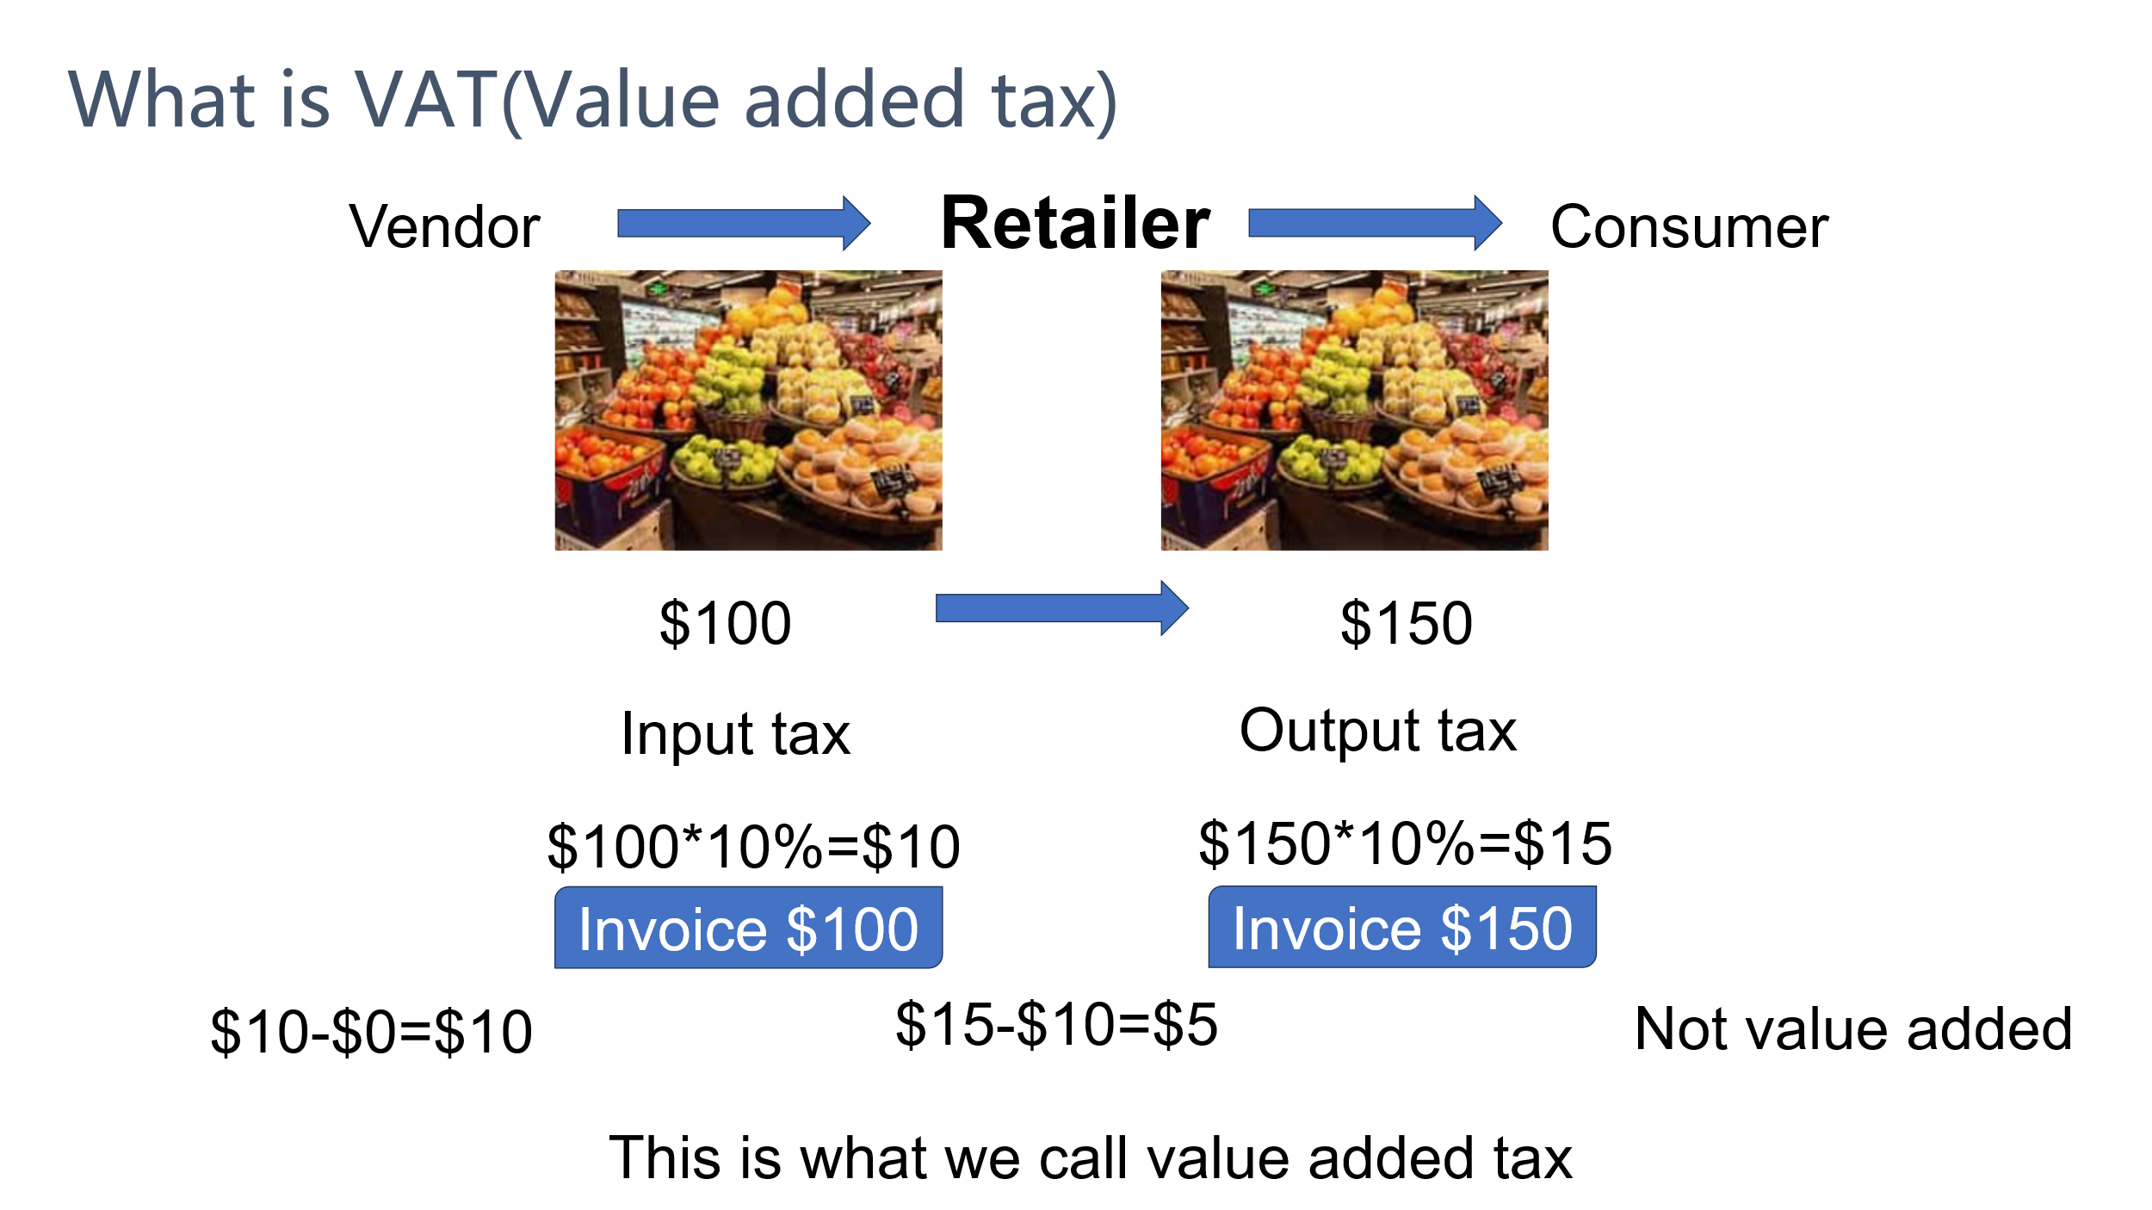

Figure 1

Suppose the VAT rate is 10%. If a retailer purchases $100 worth of fruits from a supplier and sells them for $150, the input tax for the retailer is $100 × 10% = $10, and the output tax is $150 × 10% = $15. The VAT payable is therefore $15 - $10 = $5. Alternatively, this can be calculated based on the value added from the sale: the value added is $150 - $100 = $50, so the VAT is $50 × 10% = $5.

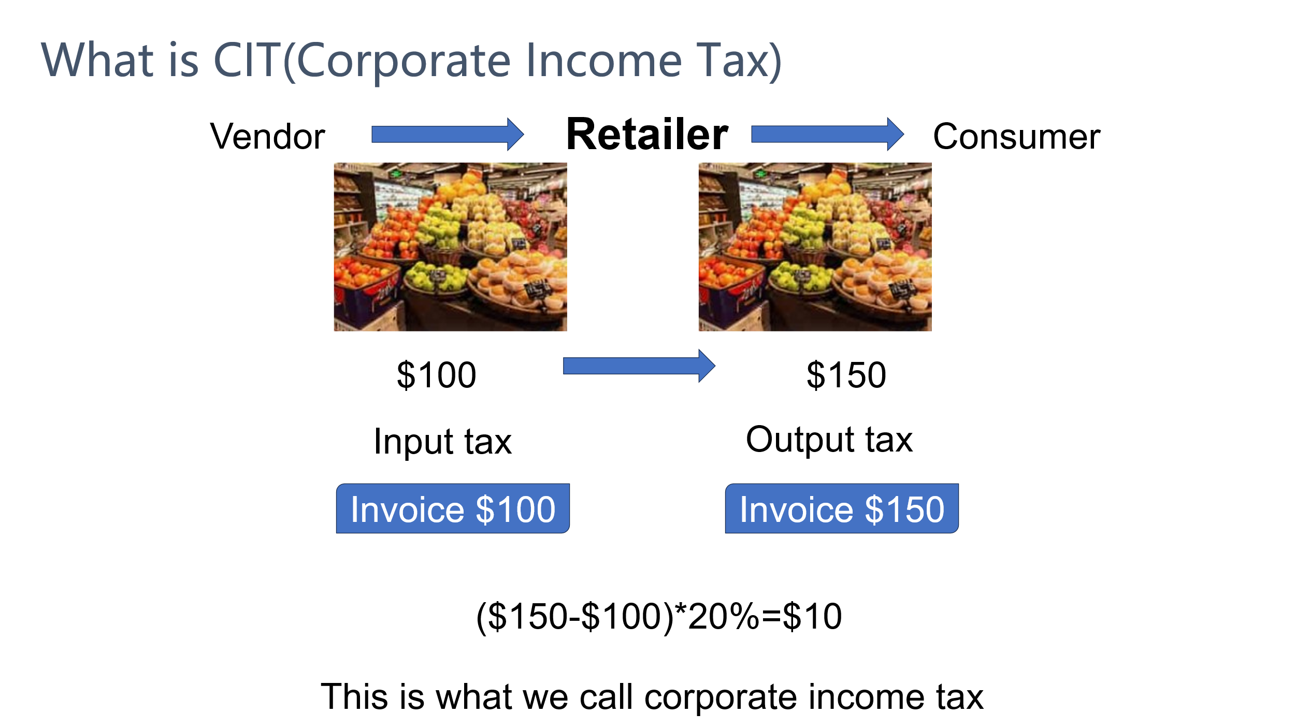

Figure 2

Assuming the corporate income tax rate is 20%, if a retailer purchases $100 worth of fruits from a supplier and sells them for $150, the retailer's profit is $150 - $100 = $50, and the corporate income tax is $50 × 20% = $10.

If the retailer only needs to pay VAT and corporate income tax, the total tax burden rate for the retailer is (10 + 10)/150 = 13.3%.

**2.** **Introduction to the Taxation System**

Generally, tax collection systems are centered around invoice systems, often referred to as invoicing systems or billing systems. After businesses or individuals issue invoices through the system and go through certain procedures, the invoicing information is transmitted to tax authorities. There are two types of invoicing systems: the traditional paper invoice system and the electronic invoice system. Electronic invoice systems are further divided into two categories: one is centralized, where invoices are created and recorded through the tax authority’s large centralized server; the other is decentralized, which uses blockchain technology to create and record invoicing information in a decentralized manner. This study focuses on the latter, i.e., the blockchain electronic invoice system.

Blockchain is a decentralized distributed ledger that records transaction information in a secure, transparent, and tamper-proof manner. Through encryption algorithms and consensus mechanisms, blockchain ensures data is synchronized and consistent among network participants without relying on a single control source. An invoicing system based on blockchain technology gives each electronic invoice uniqueness and strong anti-counterfeiting properties. In contrast, paper invoices use hardware encryption technology and anti-counterfeiting coatings similar to banknotes to encrypt and prevent counterfeiting, ensuring the uniqueness and non-tamperability of invoices.

As early as 2018, China leveraged the characteristics of blockchain to develop a tax invoicing system. In August 2018, the Shenzhen Guomao Revolving Restaurant issued the first national blockchain electronic invoice. As of October 27, more than 7,500 enterprises in Shenzhen had registered to use blockchain electronic invoices, issuing over 9.75 million invoices involving an amount of $6.93 billion, covering multiple livelihood sectors such as catering, retail, transportation, and accommodation.[3]

How do tax authorities collect taxes from trade between retailers and suppliers? Take VAT as an example. As shown in Figure 3, after the supplier issues an invoice to the retailer, the tax authority establishes a tax claim against the supplier for the output tax payable. Upon receiving the invoice from the supplier, the retailer obtains $10 in input tax, which can be used to offset output tax. After the retailer sells the goods and issues an invoice, the tax authority has a $15 claim against the retailer (i.e., the retailer’s output tax is $15). However, because the retailer holds $10 in input tax, the retailer only needs to pay $5 in VAT. Ultimately, the total tax collected by the tax authority is $10 from the supplier plus $5 from the retailer, totaling $15.

Income tax does not require deduction calculations through the tax system but relies on accounting firms to verify the authenticity of invoices and issue audit reports. However, the manual verification methods used by accounting firms are less accurate than those of the tax system. Therefore, it is easier for enterprises or individuals to evade income tax than VAT—for example, by manually printing extra invoices or colluding with auditors through bribery to participate in tax evasion fraud.

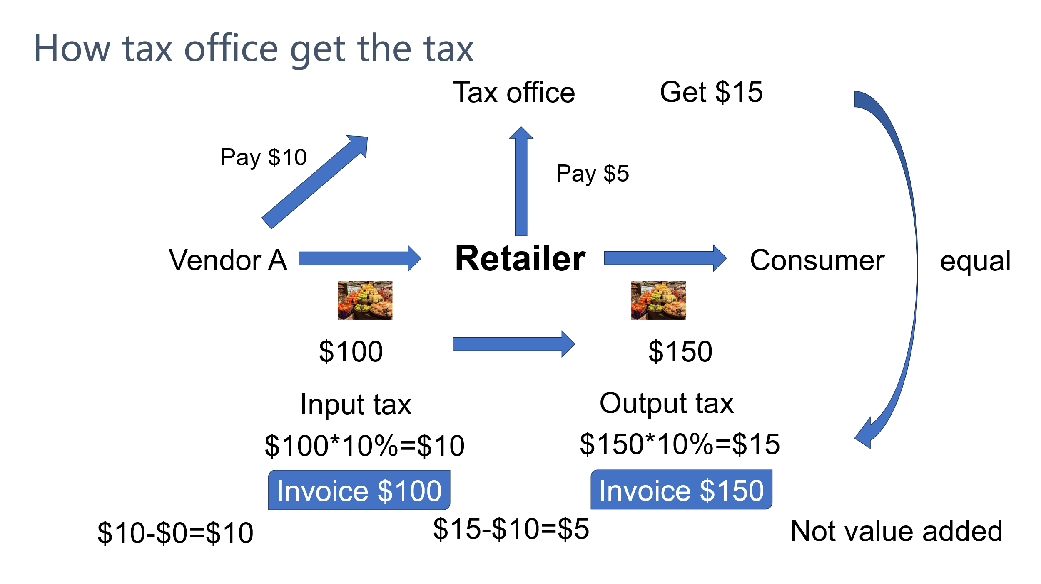

Figure 3

**3. Introduction to Common Tax Evasion Methods**

If there are only two circulation stages for a product from production to consumption, namely from supplier to retailer and from retailer to consumer, there are also only two stages where tax evasion can occur: either by the supplier or by the retailer. If the supplier evades taxes, as the source of the product's circulation, it can only evade taxes at the sales stage by underreporting or underdeclaring sales revenue, thereby paying less or no tax.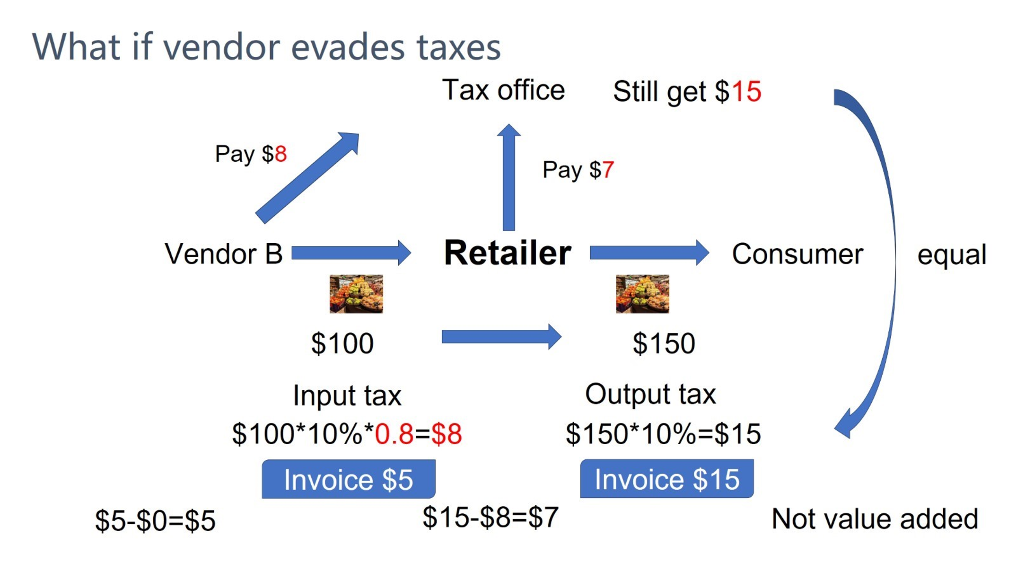

Figure 4

Taking the circulation of value-added tax (VAT) as an example, suppose the supplier only declares 80% of the actual sales amount. As shown in Figure 4, the tax it needs to pay to the tax authority will be $8 ($100 × 10% × 80% = $8) instead of $10 ($100 × 10% = $10). Since the invoice received by the retailer from the supplier also reflects $8, the retailer can only obtain $8 in input tax. When the retailer sells the goods at $150, its output tax is $15, so the tax it needs to pay to the tax authority is $15 - $8 = $7. In the end, the total tax received by the tax authority is $8 from the supplier plus $7 from the retailer, totaling $15. If the supplier does not evade taxes, the tax collection process will be as shown in Figure 3, and the tax authority will also receive $15 in the end. This means that if the supplier evades taxes, it can pay less tax, but the tax burden on the downstream retailer increases, while the tax authority's revenue remains unaffected. Therefore, tax authorities do not actually focus much on tax evasion by upstream enterprises.

Next, consider the case of retailer tax evasion. Retailers can evade taxes in two stages: one is the sales stage, where they can underreport sales amounts, and the other is the procurement stage, where they can inflate procurement amounts by purchasing fake invoices.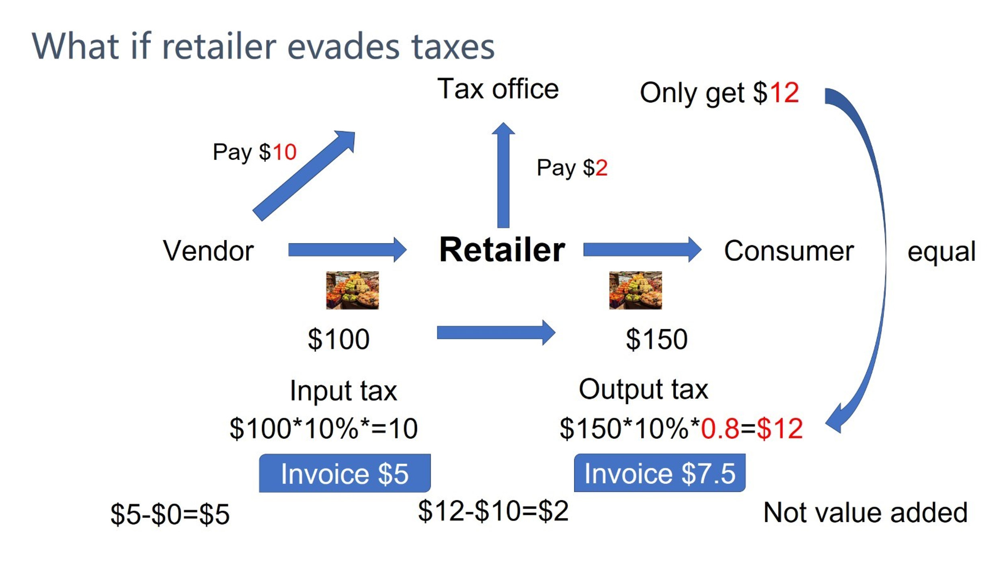

Figure 5

Let’s start with the first scenario: tax evasion at the sales stage. As the final link in the commodity circulation chain, the invoices issued by retailers during sales cannot be used as input tax credits by consumers in the next stage, as most end consumers are individuals who do not use invoices for input tax deductions. Thus, the retailer effectively represents the last link in the circulation chain. If the retailer underreports sales to reduce its output tax liability, as exemplified by the supplier in Figure 4, it will lead to tax revenue losses for the tax authority. As shown in Figure 5, when the retailer declares only 80% of its actual sales, it only needs to pay $2 ($12 - $10 = $2) in taxes. Consequently, the tax authority collects only $10 from the supplier plus $2 from the retailer, totaling $12—$3 less than the expected $15. This makes tax evasion inspections at the retailer’s sales stage far more critical for tax authorities than those targeting suppliers.

Another form of retailer tax evasion occurs at the procurement stage, typically through purchasing fraudulently issued VAT invoices. Criminal actors may establish shell companies, fabricate large sales records, issue numerous fake invoices in a short period, and sell these invoices to retailers at low prices. These criminals then evade legal repercussions by declaring bankruptcy or emigrating.

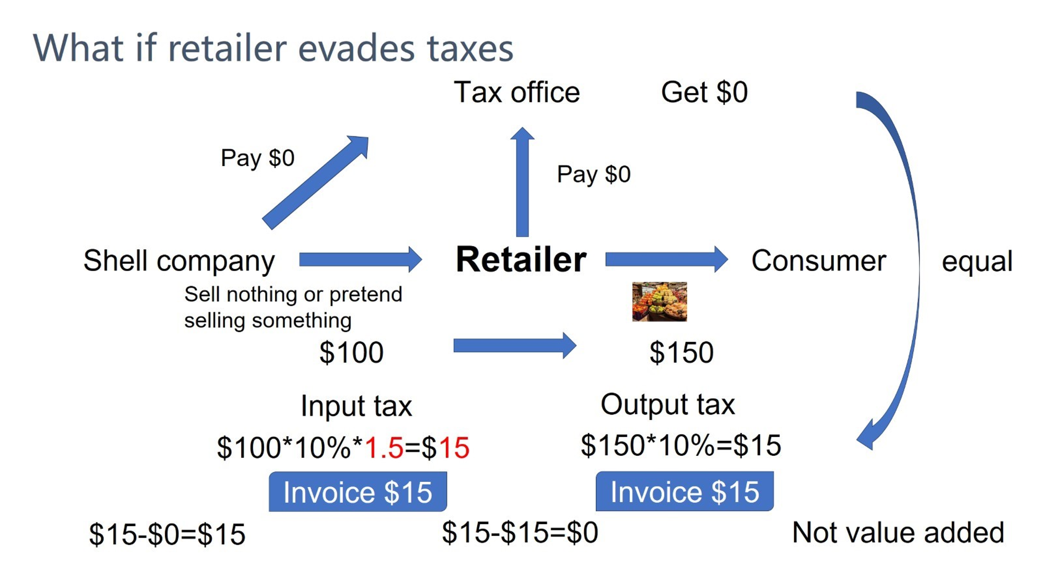

Figure 6

As shown in Figure 6, the retailer additionally purchases invoices equivalent to 0.5 times the tax amount from shell companies, allowing the retailer to have $15 in input tax. Since the retailer's output tax is also $15, it ultimately does not need to pay any tax to the tax authority.

The examples above all involve VAT evasion. Compared to VAT, income tax does not have a deduction mechanism, as VAT is a circulation tax while income tax is not. Tax evasion methods for income tax are similar to those for VAT: evasion can occur by purchasing fraudulently issued invoices during the procurement stage or by underreporting sales during the sales stage. The difference is that if a supplier underreports sales for income tax, the tax authority’s revenue will decrease.

The next chapter will introduce the technical principles by which blockchain-based electronic invoicing systems enhance audit success rates to reduce tax evasion. Through blockchain technology and electronic information technology, such systems can not only reduce the issuance of a large number of fraudulent invoices by shell companies in a short period but also leverage the anti-counterfeiting properties of blockchain to mitigate tax evasion through repeated invoice printing and underreported sales.

**Literature Review**

Currently, there is relatively little research on blockchain-based electronic invoices, with scholars' studies in this field primarily focusing on two aspects. One aspect is the technical feasibility of integrating blockchain technology with electronic invoicing systems, which has been relatively more explored. The other aspect is the economic feasibility, examining whether the system can bring economic contributions, which has been less researched. This paper mainly focuses on the economic impact of blockchain electronic invoicing systems, falling into the latter category. Of course, this thesis also explores the basic principles of blockchain and analyzes the blockchain electronic invoicing system from a fundamental perspective.

**1. The Anti-counterfeiting Principle of Paper Invoices**

Before the emergence of electronic invoicing systems, many countries used paper-based invoicing systems. Currently, while many countries still rely on paper invoices, tax authorities in numerous nations have adopted electronic invoicing systems. To investigate the economic impact of blockchain-based electronic invoicing systems, it is essential to use paper invoicing systems as a comparison.

The anti-counterfeiting principles of paper invoicing systems across countries are largely similar, primarily relying on anti-counterfeit codes or anti-counterfeit coatings on paper invoices. Take China's pre-2018 paper invoicing system as an example: integrating computer, microelectronics, optoelectronic technology, and data encryption, this system eliminated manual invoicing and used an anti-counterfeit tax control billing subsystem to issue invoices via computer. With invoices at its core, the system provided robust monitoring at every stage, from source control during invoice issuance, anti-counterfeiting and tax calculation during invoice filling, forgery detection during invoice deduction, to tax reporting for special VAT invoices. This achieved a dual effect of anti-counterfeiting and tax control for special VAT invoices. The following details the anti-counterfeiting methods of paper invoices.

**I. Invoice Source Control**

Before issuing a special VAT invoice, an enterprise's finance department first purchases invoices from the tax authority with a tax control IC card. While purchasing paper invoices, the tax authority writes the electronic information of the invoice purchase into the enterprise's tax control IC card. The invoice code and number on each invoice are unique. After returning to the enterprise, the finance department can issue invoices by reading the new invoices into the billing subsystem on the office computer. The billing subsystem automatically uses the invoices sequentially starting from the first serial number until they are all used up. If there are no newly purchased invoices, the system will automatically close and cannot continue issuing invoices.

**II. Anti-counterfeiting Principle**

During the invoicing process, the encryption function provided by the billing subsystem is used to encrypt the main content of the invoice to form a secure electronic ciphertext, which is printed on the invoice. The system employs internationally advanced encryption algorithms and cryptographic mechanisms to ensure that the password for each special VAT invoice issued by each billing machine is unique and corresponds to various parameters on each invoice, such as the invoice amount, invoice recipient, and other information. Therefore, the information of any two invoices cannot be completely identical, meaning that each invoice is unique.

**III. Forgery Identification Principle**

When an enterprise receives an invoice that appears to be issued by the anti-counterfeit tax control billing subsystem, it can take the invoice to the tax authority to verify its authenticity. The principle of forgery detection is as follows: the tax authority uses a high-speed scanner to automatically input the ciphertext and plaintext images on the invoice into a computer. Character recognition technology is then used to convert the images into digital information. The ciphertext on the invoice is decrypted and restored, and then compared with the plaintext. Since each anti-counterfeit special VAT invoice has a unique ciphertext for each invoice, a consistent comparison result indicates a genuine invoice, while a discrepancy indicates a counterfeit. In addition, the paper material of the invoice is coated with anti-counterfeit paint, which is also one of the anti-counterfeit measures. [4]

**IV. Tax Source Control**

To achieve the purpose of monitoring the tax amount of special VAT invoices through the anti-counterfeit tax control system, each time an invoice is printed, the billing subsystem records the transaction amount, tax amount, serial number, and invoice usage in the tax control device. The tax control device is similar to a black box on an airplane: once data is written, it can only be read and cannot be modified.

There are two types of paper invoice systems, and the anti-counterfeit principles introduced above are the same for both. The difference between the two paper invoice systems lies in the upload of invoice data. Before the popularization of the internet, invoice data was mainly uploaded to tax authorities via IC cards. During the monthly tax declaration period, enterprises were required to use tax control IC cards to copy the tax declaration data from the black box and file tax returns with the tax authorities on time. Otherwise, the billing system would automatically lock up, disabling operations such as issuing invoices. [5] This system is referred to as the Paper Invoice System V1.0 in this thesis, while the V2.0 system relies primarily on the internet for data upload.

The operating principle of the V1.0 paper invoice system is shown in Figure 8. Each month, suppliers first obtain a fixed quantity of invoice papers coated with anti-counterfeit materials from the tax authority and print invoices through specialized printers when selling goods. Invoices generally have three copies, all with the same content. One copy is the accounting copy, serving as the original document for accounting, the basis for tax authorities to calculate output tax, and the legal basis required for audit firms to issue audit reports. The remaining two copies are the deduction copy and the accounting copy, both of which are provided to the retailer. The deduction copy is the retailer’s input tax voucher for offsetting output tax, while the accounting copy serves as the basis for the retailer’s bookkeeping.

Retailers issue invoices in the same manner when making sales. During the declaration period, they take the deduction copy sent by the supplier and the accounting copy issued during their own sales to the tax authority for settlement. The tax authority verifies whether there are errors in the retailer’s tax calculation process by manually checking the purchase and sales amounts.

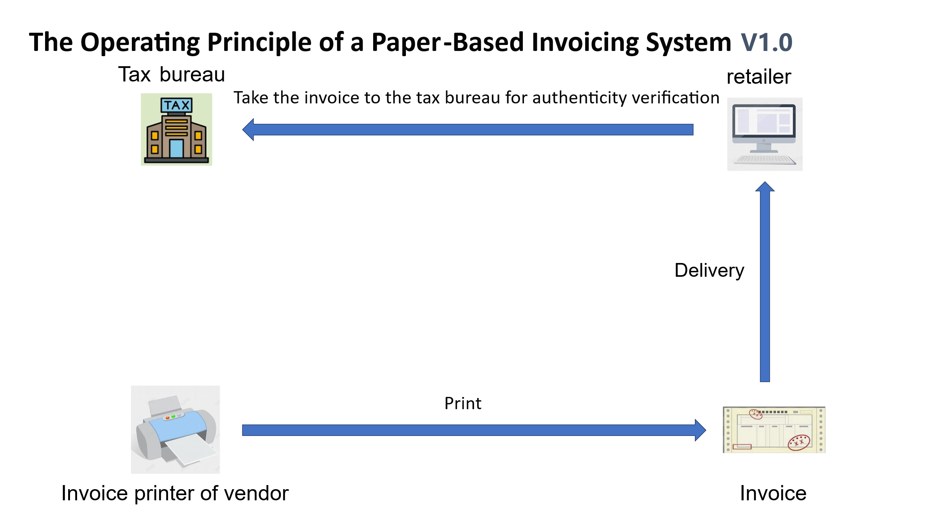

Figure 7

The main difference between V2.0 and V1.0 lies in the method of uploading invoicing data, while the anti-counterfeiting principles remain largely the same. As shown in Figure 9, when a supplier sells goods and issues an invoice, the "black box" of the invoicing system records the invoicing information, which can only be read and not modified. At the end of the month, the supplier uploads the black box data to the tax authority via the internet.

Compared to V1.0, the V2.0 paper invoicing system significantly improves data upload efficiency. However, it still cannot address the issue of fraudulent issuance of a large number of invoices in a short period. This is because whether it is retailers or suppliers, if they remain offline and do not use IC cards to read the black box data, tax authorities cannot obtain real-time invoicing information of enterprises or individuals.

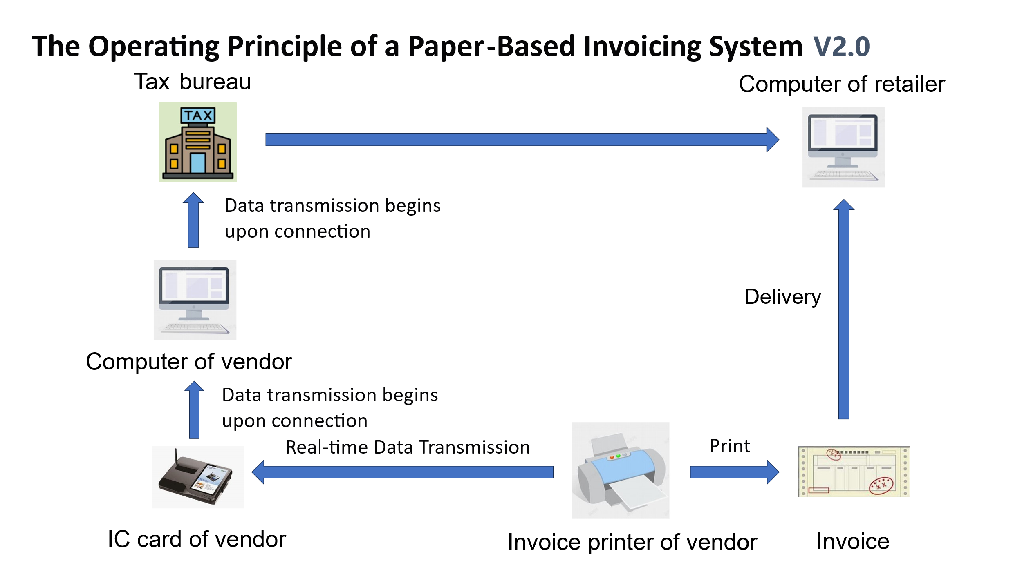

Figure 8

**2.** **Methods of Tax Evasion with Paper Invoices**

There are mainly the following types:：

I. Paper invoices serve as the original vouchers for accounting and are the basis for tax calculation. Some enterprises will reprint paper invoices and use them as expense vouchers, which is very useful for evading income tax.

II. Some businesses refuse to print invoices for consumers on the grounds that the printer is broken or the monthly invoicing amount/quantity has reached the limit. Some consumers do not request paper invoices after consumption, allowing businesses to avoid issuing invoices or sell them to other enterprises.

III. The IC card records the amount of paper invoices issued by an enterprise. Only after being connected to the network can the invoicing amount be uploaded to the tax authority through computer operations. Since the data is not uploaded in real time, there is more room for the illegal operation of issuing false invoices. Shell companies can issue a large number of false invoices within a short period, and the tax authority has no way of knowing.

IV. There are top-notch hackers who can modify the IC card. They can print out paper invoices while the IC card records no data at all. Or they can create huge input tax invoices out of thin air for themselves to reduce the tax amount.

**3. Anti-counterfeiting Principle of the Blockchain Electronic Invoice System**

Since its inception, blockchain technology has been known for its characteristics of distributed ledger and tamper-resistance. Proposed by Satoshi Nakamoto in 2008, blockchain was initially used for the construction and transactions of Bitcoin. [6] A blockchain consists of a series of blocks linked together via cryptographic hashes to form a continuous chain [7]. Each block contains a reference to the previous block, creating an unbroken blockchain [8]. Once data is recorded on the blockchain, it becomes extremely difficult to tamper with or delete [9]. This distributed ledger technology ensures that all participants in the network have access to the complete transaction history. In a blockchain network, there is no central authority overseeing the data; instead, data is shared across network servers, which can be either private or public [10]. Blockchain networks are divided into two types: permissioned blockchains, which restrict access to transaction details for specific participants, and permissionless blockchains, which allow all network members to view all transaction details [8]. Blockchain technology provides security, trust, data integration, and anonymity without the need for third-party intermediaries [11].

Thus, blockchain technology fully enables the possibility that electronic invoices generated by a blockchain-based invoicing system are unique and tamper-proof, and users related to the electronic invoice (such as suppliers, retailers, consumers, and tax authorities) can query relevant information about the invoice. If the invoice has been used to offset VAT, as an expense for corporate income tax deduction, or for employee reimbursement, the status of the invoice will be updated and cannot be altered, eliminating the possibility of repeated invoice deductions or reimbursements.

In the research of Du Li and Zheng Yuwen, we can deduce that the invoicing system of the Shenzhen Tax Bureau adopts a similar model. [12] Milla Sepliana Setyowati et al. noted that traditional invoicing systems are centralized, requiring consumers to verify received invoices, while a blockchain-based invoicing system can eliminate the invoice verification process. [13] Shenzhen’s tax system has implemented this feature, allowing consumers to directly reimburse invoices without verification. [14] Milla Sepliana Setyowati et al. also mentioned that blockchain’s smart contract technology can ensure taxpayers pay taxes to the national budget in real time and automatically on the transaction date, significantly improving tax compliance and reducing tax evasion risks. Blockchain can not only mitigate VAT evasion risks but also apply to individual income tax on employee wages—during salary transfers, payroll taxes can be automatically captured and paid to the treasury, eliminating employers’ obligations as tax collectors. [13] In *"A Blockchain-based Value Added Tax (VAT) System: Saudi Arabia as a Use-Case"*, Ahmad Alkhodre et al. explored a blockchain-based VAT collection system where each company’s invoicing system acts as a blockchain node, theoretically and technically proving the feasibility of blockchain in transparent VAT invoicing. To collect VAT, the system’s infrastructure is built on the Hyperledger Fabric platform, integrating entities across the supply chain management domain. The network consists of a server cluster including order nodes, Certificate Authorities (CAs), and peer nodes. Saudi Arabia’s VAT collection framework is hosted on this cluster, overseeing and maintaining all logical components, including consensus mechanism establishment and CA operations [15]. Although their paper does not detail the system, it is evident that they aim to build a system where all companies can join as nodes. A limitation of the article is its failure to recognize that invoices are the foundational link in VAT collection, leading to a model not designed around invoices.

In terms of technical details, many scholars have conducted algorithmic research. For example, Thong Bui et al.’s *"Blockchain-Based Decentralized Digital Content Management and Sharing System"* [16] introduces a digital contract sharing model, whose sharing algorithm can be applied to electronic invoices to establish a sharing mechanism between invoice issuers and holders. Shreerang Bhat et al.’s *"Blockchain-Based System for Storing Warranty Receipts"* describes a blockchain-based warranty receipts model, where replacing "warranty receipts" with "invoices" would expand the model’s and algorithm’s applicability [17]. Kean-Wah Cheng and Swee-Huay Heng’s *"Blockchain-Based Content Sharing and Data Repository System"* details blockchain sharing and storage mechanisms, with storage technologies and algorithms applicable to electronic invoices [18].

Finally, on GitHub, open-source blockchain-based invoice management or invoicing systems have already been developed. Although the code is not yet mature for large-scale real-world applications, it demonstrates the feasibility of such systems. As early as 2017, a user named rigelrozanski open-sourced blockchain-based invoicing system code [19]. Additionally, sriram-kakarala and others have open-sourced related code [20]; searching for keywords "blockchain" and "invoice" on GitHub yields numerous open-source projects.

After confirming the technical feasibility of applying blockchain technology to electronic invoicing systems, it is necessary to investigate its economic feasibility: whether the system can truly bring more revenue to tax authorities and benefits to market enterprises, making them willing to adopt the new system. Soohyun et al. assumed two manufacturers and one retailer—one manufacturer under-issues invoices, the other does not—and used a three-party game to determine the system’s impact on individual and overall interests [21]. However, the blockchain system described in this paper differs from the blockchain electronic invoicing system explored here; the authors do not detail the system model, but it can be inferred that their system is a retailer-centered private blockchain rather than a tax authority’s invoicing system.

**4.** **Technical Advantages of the Blockchain Electronic Invoice System**

There are mainly the following points:

I. The behavior of reprinting invoices will be completely eliminated. Because after an enterprise uses an invoice to deduct value-added tax and income tax, the corresponding status of the electronic invoice will be modified, and this status cannot be tampered with.

II. There is no limit on the amount of blockchain electronic invoices, nor is there any printing requirement. Merchants will issue electronic invoices for 100% of each sales transaction. The invoicing system is linked to the merchant's bank account. As long as the consumer makes a payment, the merchant's invoicing system will automatically issue an invoice.

III. The invoicing data is transmitted to the tax authority in real time. Therefore, the behavior of shell companies issuing a large number of false invoices within a short period of time will be stopped. This is because once the daily invoicing amount of these shell companies reaches a certain upper limit, it will be monitored by the tax authority.

IV. It is more difficult for hackers to attack the blockchain invoicing system than to hack an IC card. If a hacker wants to tamper with the invoicing data, the nodes they need to hack are not just one enterprise, but all the enterprises on the blockchain nodes.

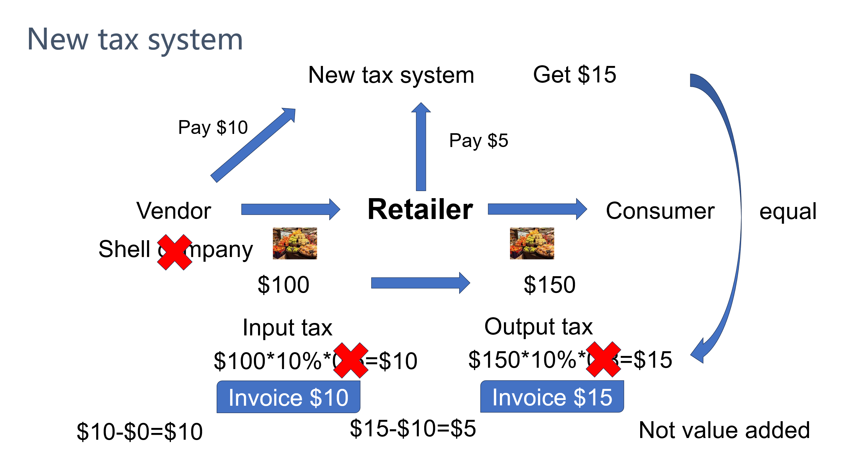

Figure 9

Compared with paper invoices, blockchain-based electronic invoices have the characteristic of real-time access to invoicing data. This prevents shell companies from issuing a large number of invoices in a short period and then evading legal sanctions. Once a shell company issues a large number of high-value invoices in a short time, the tax system can monitor anomalies in real time. If the shell company cannot provide convincing evidence to prove the legitimacy of its issuance of high-value invoices, it must repay the taxes and pay fines to the tax authority. Of course, shell companies may still attempt to sell a small number of fraudulently issued invoices within a short period. However, if they fail to file tax returns and pay taxes on time after one month, tax authorities will conduct on-site inspections, forcing criminals to pay taxes and fines. Unless they can issue a large number of invoices to achieve financial freedom in a short time, their only options are to take the risk of imprisonment for a small reward within a month and then declare bankruptcy or flee overseas. For criminals, such risks may not be proportional to the rewards. For tax authorities, although there is still a possibility of losing a small amount of tax revenue, the situation is significantly better than under the paper invoice system.

From a technical perspective, compared with the paper invoice system, the blockchain-based electronic invoicing system can effectively improve the audit success rate of tax authorities, thereby reducing the market tax evasion rate.

**5．Comparison between the Paper Invoice System and the Blockchain Electronic Invoice System**

In addition to reducing the tax evasion rate, the blockchain electronic invoicing system has several other advantages over the paper invoicing system. The following table compares the characteristics of the two systems.

|  |  |  |
| --- | --- | --- |
|  | Paper Invoice System | Blockchain Electronic Invoice System |
| **Printing** | Requires a specialized printer and invoice paper for printing. | Does not require printing; the electronic version can serve as the original document for accounting and for inspection by audit bureaus and tax authorities. If printing is needed, any printer and paper can be used. |
| **Quota** | Tax authorities impose restrictions on the monthly quantity and amount of invoices a business can issue to control risks of fraudulent VAT invoices. Additional applications to the tax bureau are needed if the quota is exceeded. | Larger quotas are available, and applications can be made online at any time. |
| **Mailing** | Physical invoices need to be mailed between upstream and downstream enterprises for tax deduction purposes. | Invoices can be directly sent via digital tools such as email and WeChat without the need for mailing. |
| **Reimbursement** | Physical invoices are required for reimbursement, and there may be cases of duplicate reimbursement, especially when an enterprise's financial reimbursement process is not standardized—for example, photocopied paper invoices can still be used for reimbursement. | Only the electronic version is needed for reimbursement, which eliminates cases of duplicate reimbursement. At the same time, employees no longer need to worry about being unable to claim reimbursements due to lost paper invoices [25]. |
| **Duplicate Deduction of Income Tax** | The same invoice may be used by enterprises as an expense in different periods. By overstating expenses in this way, enterprises can reduce their income tax liability (e.g., the same invoice may be recorded as an expense for two different months or years). | Once declared, an invoice is stamped with a timestamp, making duplicate deductions easily detectable. |
| **Financial Efficiency** | Each financial document requires physical invoices to be bound and organized. | Only electronic documents need to be organized, which greatly facilitates audits by accounting firms. |
| **Timeliness** | Paper invoices are encrypted by tax control machines for anti-counterfeiting, but the invoicing data cannot be uploaded to the tax bureau in real time, leaving significant room for fraudulent VAT invoice issuance. | Invoicing data is uploaded to the tax bureau in real time. Large-scale fraudulent invoicing within a short period can be easily detected by the tax authority. |
| **Financial Risks** | Some enterprises create false accounting records for bank loans, inflating revenue through fake invoices to boost reported profits and secure more loans. | With blockchain technology, the authenticity of invoices can be easily verified, making invoice fraud extremely difficult. |
| **Communication Efficiency Between Enterprises** | During mailing, the invoice amounts between upstream and downstream enterprises often differ from previously agreed values, increasing communication costs. | Invoices can be sent in real time. If discrepancies in amounts are found, enterprises can communicate and resolve issues on the same day. |

Table 1

From the above table, it can be seen that the blockchain electronic invoicing system appears to be much more convenient than the paper invoicing system. However, it is also necessary to consider whether the benefit improvement brought by the blockchain electronic invoice and the costs invested by tax authorities are reasonable. On Zhihu, China's largest knowledge Q&A platform, many financial professionals have complained that the system actually increases workload and fails to improve enterprises' economic efficiency. The above content only represents the views of netizens who left comments on the post, and for details, please visit: https://www.zhihu.com/question/509805193.

The blockchain electronic invoicing system still has other shortcomings. Although China's blockchain electronic invoicing system is already quite mature, there are still issues in the storage of electronic invoices. For example, consumers do not have a dedicated electronic invoice application, so they cannot centrally store all invoices from daily consumption in one app. One reason is that local tax authorities have not yet launched related applications, and currently, invoices can only be stored in personal email accounts or saved on mobile phones in the form of QR codes. The second reason is that the database systems of tax authorities in different regions have not yet been interconnected, while a national unified tax database is the future development trend. In fact, global electronic invoices could also be based on the same blockchain platform, which would reduce the possibility of enterprises forging import goods invoices in international trade. K. Narayanam et al. have proposed a global electronic transportation invoicing system based on blockchain technology [22].

The relationship between enterprises and tax authorities remains a cat-and-mouse game. Although tax authorities may not be able to completely prevent business owners from evading taxes, this system has reduced the occurrence of tax evasion to a certain extent, and ultimately enhanced economic efficiency and social equity.

**Methodology**

This thesis employs literature research and computer simulation methods. The literature research method is primarily used to study the basic content of blockchain invoicing systems and paper invoicing systems, as well as the principles required for model construction. In the verification stage, the reason for adopting computer simulation instead of empirical research is that real-world tax evasion data is extremely difficult to obtain. For example, we never know how many enterprises in the market are evading taxes or what their tax evasion rates are. For instance, if tax authorities detect ten tax-evading enterprises in a market with a total of one thousand enterprises within a year, this does not mean the tax evasion rate in this market is 10%. Similarly, to protect personal privacy or due to poor statistical work by tax authorities, the official websites of tax authorities in many countries do not disclose certain tax evasion data.

Regarding the amount of tax evasion, few countries conduct research on relevant data. Taking the United States as an example, according to estimates by the U.S. Department of the Treasury, the "tax gap" (the difference between taxes owed and taxes collected) totals approximately $600 billion annually [23]. In 2022, the amount of tax evasion in the U.S. accounted for approximately 15% of the taxes that should have been paid [24]. According to data from the European Commission, EU countries lost €134 billion in VAT revenues in 2019 [25].

Although this paper uses computer modeling for reasoning, it does not mean the data is disconnected from reality. Efforts will be made to make aspects such as the tax evasion rate as close to reality as possible.

In the field of economic simulation, there are two common simulation methods: DSGE (Dynamic Stochastic General Equilibrium) and ABM (Agent-Based Modeling). DSGE is the mainstream framework in modern macroeconomics for analyzing business cycles, policy shocks, and how micro-foundations align with macro phenomena. In 1928, Frank P. Ramsey first established the intertemporal optimization dynamic general equilibrium framework in *A Mathematical Theory of Saving* to study the social optimal savings rate [26]. In the 1960s–1970s, economists such as Tjalling Koopmans and Lionel McKenzie formalized dynamic optimization and general equilibrium theory [27][28]. In 1982, Finn E. Kydland and Edward C. Prescott introduced technological shocks and optimization methods in their paper *Time to Build and Aggregate Fluctuations*, proposing the Real Business Cycle (RBC) model, marking the official birth of the "neoclassical dynamic general equilibrium" (i.e., DSGE) framework [29]. Clarida, Gali, and Gertler (1999) built on RBC by introducing price and wage stickiness and the Calvo-Taylor rule, forming the prototype of the new Keynesian DSGE [30].

ABM (Agent-Based Modeling) is a computer simulation method that studies macro phenomena in complex systems by simulating the behaviors and interactions of autonomous decision-making individuals (agents) in specific environments. Joshua M. Epstein and Robert Axtell (1996) published *Growing Artificial Societies: Social Science From the Bottom Up*, creating the large-scale economic-sociological ABM platform "Sugarscape" to explore macro-emergent phenomena such as wealth distribution, epidemics, and cultural diffusion [31]. Leigh Tesfatsion launched the *Agent-Based Computational Economics (ACE)* special issue in 2001, standardizing the methods and criteria for economic ABM [32].

Compared to DSGE, ABM is more flexible with a less fixed framework, allowing the definition of individuals in economic activities from the most fundamental micro level. Therefore, the computer simulation in this thesis will be based on the ABM method.

There are many ways to build ABM models, including mature platforms like NetLogo and self-constructed models through Java or Python programming. This paper uses Python code to build its own simulation model, stores the simulated data in Excel for data analysis, and employs Excel's data statistics functions and Python programming for analysis.

**Data Results and Analysis**

1. **Introduction of the Model**

The quantity theory of money is a monetary theory that explains changes in commodity prices through fluctuations in the quantity of money in circulation. [33] The principles of money circulation and commodity circulation in this thesis' model are also based on the quantity theory of money. The reason for using the quantity theory of money is that money is quantifiable, money measures prices, and prices can measure value. In this model, the total amount of money remains constant. Combining with the basic formula of the quantity theory of money, MV=PY, it can be seen that when the total amount of money M and the commodity price P remain unchanged, changes in other parameters in the market, such as the tax authority's audit success rate and the cost of the blockchain electronic invoice system studied in this thesis, will affect the velocity of money circulation V and the commodity output Y. The indicators used in this model to measure economic efficiency and social equity also derive from these two parameters, i.e., using the velocity of money circulation to measure economic efficiency and the asset ratio to quantify the degree of social equity.

Given that the total amount of money is fixed, to better measure economic efficiency and social equity with money, the market designed in this thesis is a closed market where commodities and money only trade within one market without outflow, and only one type of currency is designed. This is done to make the simulation process clearer and more intuitive. If the market's trade were not closed, the model would need to consider factors such as foreign currency and foreign exchange, which would not only complicate the simulation process but also make it more difficult to understand and increase the probability of errors.

In addition, the model designs only two types of commodities, rice and meat, and two types of producers, farmers ($F_{i}$) and herdsmen($H_{i}$) (𝑖∈𝑔, 𝑏, 𝑛). Farmers can only produce rice, while herdsmen can only produce meat. Carbohydrates and proteins are essential nutrients for the human body, so meat is a necessity for farmers, and rice is a necessity for herdsmen. In this way, the market's trading mechanism is formed: farmers purchase meat daily to meet their nutritional needs, while herdsmen purchase rice to meet theirs. Money acts as a medium in commodity transactions, with sellers obtaining money and buyers consuming money. Money can measure both daily transaction volumes and the final assets owned by farmers and herdsmen.

The agents designed in this model involve three roles: the tax bureau ($T$), farmers ($F_{i}$) and herders ($H_{i}$) (𝑖∈𝑔, 𝑏, 𝑛). Among the farmers, there is a good person $F_{g}$, a bad person $F_{b}$, and a neutral person $F_{b}$. Among the herders, there is a good person $H_{g}$, a bad person $H_{b}$, and a neutral person $H_{n}$. The initial asset $a_{i}^{j}$ $(j∈\left\{F, H\right\}$) of each of them is 100. In order to better study the economic changes under different conditions, the total amount of currency designed in this model is fixed, and there will be no phenomenon of currency outflow.

The model assumes that the daily demand of farmers is only meat, while the demand of herders is only rice. One is protein and the other is carbohydrate, both of which are essential nutrients for the human body and belong to rigid demands. However, farmers can only produce rice and not meat, and herders can only produce meat and not rice. Therefore, they have the motivation to trade with each other. The model also assumes that rice and meat are not completely homogeneous commodities, and they do not have a 100% substitution relationship. The main component of rice is carbohydrate, with a small amount of protein and fat. The main components of meat are protein and fat, with a small amount of carbohydrate. Therefore, they also have a certain complementary relationship. Moreover, the production of farmers and herders is stable. As a result, the demand curves of these two types of commodities present the shape of a concave function.

Every day, farmers and herders go to the market to buy the commodities they need. Each farmer sells a bowl of rice every day and buys a piece of meat from the herders. The herders sell a piece of meat every day and buy a bowl of rice from the farmers. However, sometimes farmers and herders also sell two bowls of rice or two pieces of meat every day, with a probability of ${prob}^{m}$, which depends on the daily financial distribution of the tax bureau. The revenue $r$ of the tax bureau comes from tax revenue $t$ and fine revenue $f$. The tax bureau will evenly distribute the daily revenue to all farmers and herders for them to carry out the construction and maintenance of public facilities, such as building roads, cleaning up fallen leaves, etc. In this thesis, building roads is taken as an example. The more funds the tax bureau allocates for road construction, the higher the enthusiasm of farmers and herders for road maintenance, and the better the maintenance level of the roads. In this way, the probability that farmers and herders transport two bowls of rice and two pieces of meat to the market every day will be higher, and finally the probability of making transactions twice a day will also be higher. Therefore, the revenue of the tax bureau is positively correlated with the probability of making transactions twice a day.

It is assumed that the probability of making transactions twice a day is ${prob}^{m}$, and the relationship between ${prob}^{m}$ and the revenue $r$ of the tax bureau is set as follows:

$${prob}^{m}=\frac{r}{6}$$

$$r=t+f$$

After arriving at the market, the good people, bad people, and neutral people among the farmers and herders will randomly match for transactions. That is, a good person may conduct transactions with a good person, a neutral person, or a bad person, and the probability of each match is equal, which is 1/3. Their purchasing desires are the same, so the probability of a transaction being completed is also the same. The seller will randomly quote a price between 2.0, 2.1 and 5.0. The higher the price quoted by the seller, the lower the market demand. And because there is a certain complementary relationship as well as a certain substitution relationship between the rice produced by farmers and the meat produced by herders, the model assumes that the demand curves of both rice and meat are concave functions. To a certain extent, the demand curve can reflect the buyer's purchasing desire, that is, the higher the price, the lower the purchasing desire, and thus the less the quantity demanded. Therefore, the model also assumes that there is a negative correlation between the price and the purchasing desire.

It is assumed that the quoted price is $p_{i}^{j}$, and the relationship between ${prob}^{b}$ and the quoted price $p_{i}^{j}$ is assumed as follows:

$${prob}^{b}=\frac{2.1}{{p_{i}^{j}}^{1.3}}$$

In order to increase the probability of a transaction, the bad people and the neutral people will sell at a reduced price. However, reducing the price will decrease their profits, so they will save costs by evading taxes. They will choose to underreport by 5%, and the tax rate is 10% of the original selling price. In this way, not only will the profit not be affected, but it will actually increase. Every day, there is an 80% probability, ${prob}_{b}^{e}$, that the bad people will evade taxes. At the same time, when quoting a price, they will underreport by 5% to increase the probability of a transaction. The neutral people have a 50% probability, ${prob}_{n}^{e}$, of evading taxes and will also underreport the price by 5%. The good people will never evade taxes, and they will pay taxes at a tax rate of $π^{t}$ = 10% of the daily transaction amount.

However, tax evasion also brings risks. If discovered by the tax bureau, the bad people and the neutral people will not only have to make up the unpaid taxes but also pay a fine equivalent to twice the amount of the evaded taxes. Every time they evade taxes, there is a probability of being discovered by the tax bureau, and the probability of being discovered is ${prob}_{t}$, which is also the success rate of the tax bureau's inspection.

After being discovered by the tax bureau for tax evasion, both the bad people and the neutral people will become timid and cautious. This period is called the cooling-off period $D_{i}$. The cooling-off period of the bad people, $D_{b}$ = 1, that is, the cooling-off period is one day. During this period, they will not evade taxes, but after the cooling-off period, their tax evasion rate will return to 80%. The neutral people have a cooling-off period of two days.

The farmers and herders in the model only need to pay value-added tax and do not need to pay income tax. And in order to avoid the closed loop of the value-added tax chain and prevent the situation of zero value-added, the farmers and herders will not be able to obtain input tax for the goods they purchase, but they need to pay output tax based on the sales amount when selling. Or this model can also be understood as only requiring the payment of consumption tax.

The following are the parameters used for computer simulation:

|  |  |  |
| --- | --- | --- |
| $$i$$ | $$g, b, n$$ | good people, bad people and neutral people |
| $$j$$ | $$F, H$$ | farmers, herders |
| $$a_{i}^{j}$$ |  | asset |
| $${prob}^{m}$$ | $${prob}^{m}=\frac{r}{6}$$ | probability of a second transaction |
| $$r$$ | $$r=t+f$$ | daily income of the tax bureau |
| $$t$$ |  | daily tax revenue of the tax bureau |
| $$f$$ |  | daily fine revenue of the tax bureau |
| $$p_{i}^{j}$$ |  | price |
| $${prob}^{b}$$ | $${prob}^{b}=\frac{2.1}{{p_{i}^{j}}^{1.3}}$$ | probability of a deal being concluded |
| $${prob}_{i}^{e}$$ |  | probability of tax evasion |
| $$π^{t}$$ | $$π^{t}=10\%$$ | tax rate |
| $$π^{f}$$ | $$π^{f}=200\%$$ |  |
| $$c$$ | $$c=0.0, 0.3 0.6, 0.9$$ | cost of the invoice system |
| $${prob}_{c}^{t}$$ |  | success rate of tax inspection |
| $$D_{i}$$ | $D_{b}=1$, $D_{n}=2$ | cooling-off period |

Table 2

1. **Simulation of the Paper Invoice System**

In this simulation, pixel points of different colors will be used to represent different roles. Green represents the living places of farmers, red represents the living places of herders, light blue represents good people, purple represents bad people, yellow represents neutral people, gray represents the market, and the blank area represents the roads. As shown in the following figure. 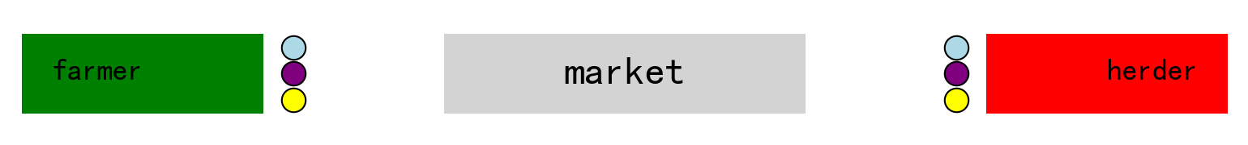

Figure 10

When the transaction starts, farmers and herders will go to the market. The transaction adopts a random matching mechanism, and good people may trade with good people, bad people, and neutral people. After the transaction is completed, they will return to their original positions. Then, on the next day, the degree of road maintenance will be calculated according to the situation of fiscal expenditure. The better the road is repaired, the greater the probability that they will carry two bowls of rice or two pieces of meat to the market on that day, that is, the greater the possibility of making transactions twice.

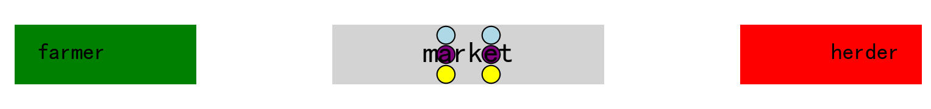

Figure 11

Based on the above model and parameters, this thesis will run a 200-day simulation on a computer, and this simulation will count the following data:

- The daily transaction amount of good people, bad people, and neutral people.

- The daily transaction volume of good people, bad people, and neutral people.

- The daily tax payment amount of good people, bad people, and neutral people.

- The daily change in assets of good people, bad people, and neutral people.

- The daily fine payment amount of good people, bad people, and neutral people.

- The probability of making transactions twice a day.

Since the success rate of inspection in the paper invoice system is uncertain, this simulation will assume that the success rates of inspection in the paper invoice system ${prob}_{0.0}^{t}$ are 0.2, 0.3, 0.4, 0.5, 0.6, 0.7, 0.8, and 0.9, and check the data results under different inspection success rates.

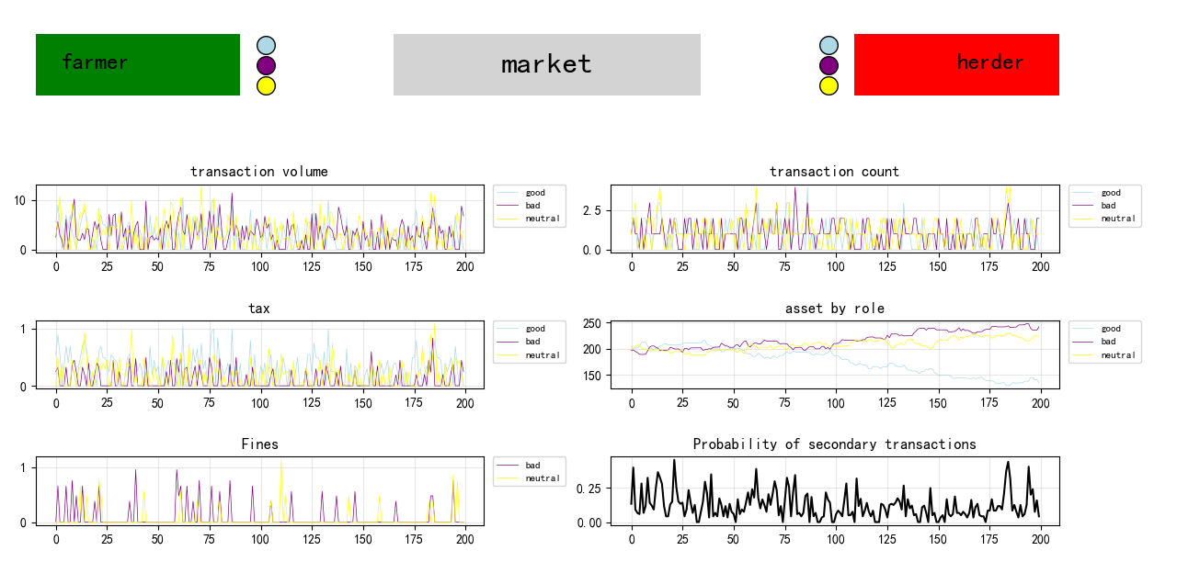

Figure 12

When ${prob}_{0.0}^{t}$ = 0.2, the simulation results are shown in Figure 12. According to the statistical chart, the fluctuation directions of the daily transaction amount, transaction volume, and tax revenue are the same. However, affected by the transaction price and the success rate of tax evasion, the magnitude of their rises and falls each time is not the same. In terms of assets, the assets of the bad people are ultimately the highest, followed by the neutral people, and finally the good people. It can be seen that within these 200 days, there was a period during which the assets of the good people and the neutral people were higher than those of the neutral people (it should be noted here that there may be a logical error in the original text as it is repeated, it might be intended to compare with the bad people), but they were overtaken close to the 200-day mark.

In terms of the magnitude of fluctuations, the transaction volume fluctuates between 0 and 15.1, the transaction count fluctuates between 0 and 4, the assets of good people, bad people, and neutral people fluctuate between 117.09 and 272.04, the tax payments fluctuate between 0 and 1.4, the fine payments fluctuate between 0 and 1.82, and the probability of secondary transactions fluctuates between 0 and 0.74.

In the case of a single simulation, the fluctuations of each data can be clearly seen, so as to analyze the relationships between each data. However, excessive fluctuations also bring problems. The results of each run may be very different, especially in asset statistics. The results of each simulation vary greatly, and there will be many possible results for the final asset rankings of good people, bad people, and neutral people, and any of them may come out on top.

In order to better analyze the data statistics under different inspection success rates ${prob}_{0.0}^{t}$ of the old and new systems, it is necessary for the simulation to eliminate the impact of excessive fluctuations. Therefore, in the subsequent analysis, the method of taking the average value after running multiple times will be adopted. All subsequent simulations will be run 3,000 times, and the data will be the average value after running 3,000 times. 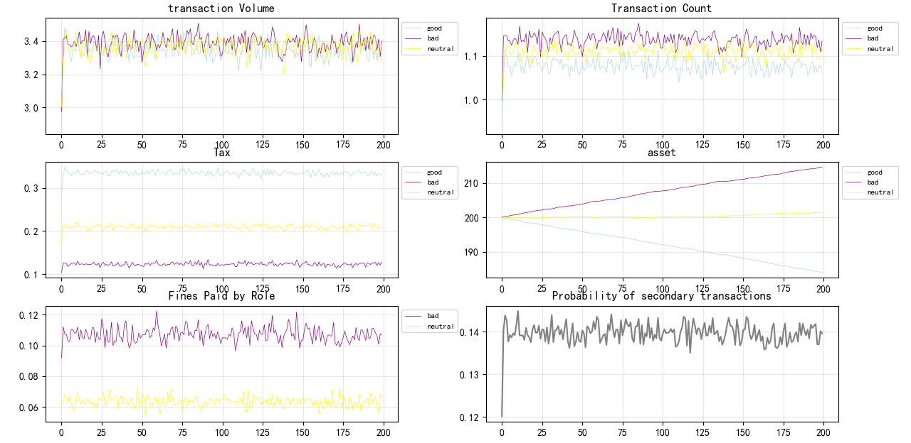

Figure 13

Figure 13 shows the results of taking the average after running 3,000 times. Compared with Figure 12, it can be seen that the value range of the vertical coordinates of all statistical data graphs has become smaller, and various curves are also much smoother. This means that the fluctuations of the data have decreased. If the number of simulation rounds is changed to more than 3,000, the results will obtain smoother curves with even smaller fluctuations. The total transaction volume stabilizes around 10, the transaction count is around 1.6. The assets of farmers and herders fluctuate between 298 and 302. The changes in the assets of good people, bad people, and neutral people present the shape of smooth curves. Among them, the assets of bad people are continuously increasing, the assets of neutral people are growing slowly, and the assets of good people are constantly decreasing. Their final assets are 214.0, 201.5, and 184.5 respectively. In terms of the revenue of the tax bureau, the tax revenue stabilizes around 0.7, the fine revenue stabilizes around 0.17, and the probability of secondary transactions stabilizes around 0.14. The tax office revenue fluctuates between 0 and 2.2, and the probability of secondary transactions fluctuates between 0 and 0.6.

We can see from the chart the favorable impact of tax revenue on transactions. When the tax bureau uses the tax revenue for public expenditure (road construction), the probability that herders and farmers transport two pieces of meat every day will increase. Therefore, the transaction amount will also rise, and the revenue of the tax bureau will increase as well. The amount used for fiscal expenditure will also increase, and finally a positive feedback is formed until the probability of secondary transactions reaches the maximum value and stabilizes around 1.4.

**2.1** **Data comparison under different inspection success rates**

In order to measure the impact of the invoice system on the economy, this article will conduct an analysis from two aspects. One is economic efficiency, and the other is the degree of social fairness. This article uses the revenue of the tax bureau and the total market trade volume to measure economic benefits. That is, the higher the revenue of the tax bureau and the market trade volume, the better the economic liquidity and the higher the economic benefits. As for social fairness, the proportion of the assets of good people on the last day will be used to measure the degree of social fairness. That is, the higher the proportion of the assets of good people, the fairer the whole society will be.

**2.1.1** **Economic benefits**

* + - 1. **Revenue of the Tax Bureau and the Probability of Secondary Transactions**

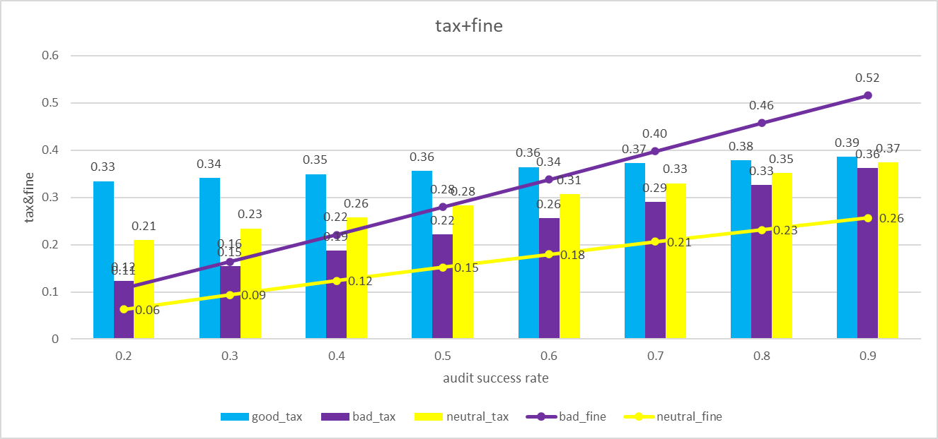

Figure 14

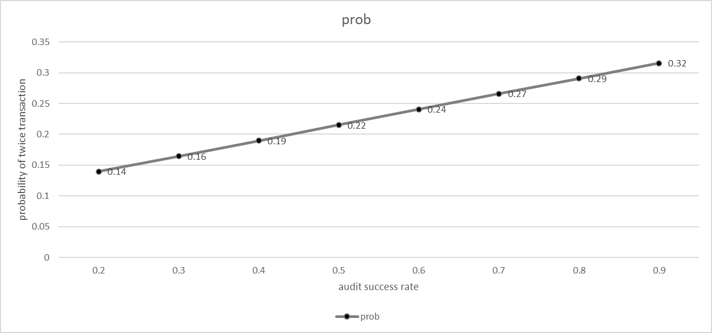

Figure 15

First, let's analyze the revenue situation of the tax bureau. It can be seen that as the inspection rate continues to increase, the taxes paid by good people, bad people, and neutral people are also continuously increasing, which means that the total tax revenue of the tax bureau is also rising. At the same time, the fines paid by neutral people and bad people are also increasing continuously, so the fine revenue of the tax bureau is also rising. After the total revenue of the tax bureau increases, the probability of secondary transactions will also continue to increase.

In terms of tax revenue, the tax payments of bad people and neutral people have increased significantly compared with those of good people. In addition to the increased probability of secondary transactions, the probability of them being inspected has also increased. As a result, not only has their success rate of tax evasion decreased, but the number of times they are in the cooling-off period has also increased. During the cooling-off period, they cannot evade taxes and can only pay taxes.

In terms of fine revenue, when the inspection rate exceeds 0.3, the amount of fines paid by bad people exceeds the amount of taxes they pay. When it exceeds 0.4, the total amount of taxes and fines paid by bad people and neutral people exceeds that of good people. This means that they have changed from beneficiaries of social public resources to contributors. **2.1.1.2 Transaction volume**

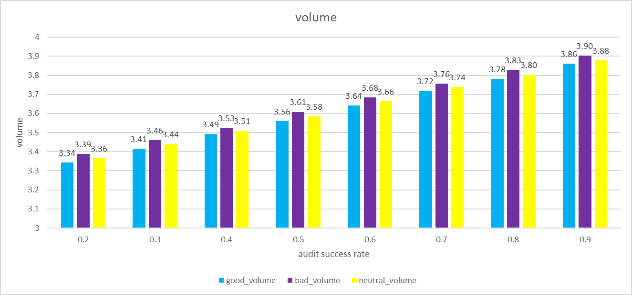

Figure 16

It can be seen that under different inspection success rates ${prob}_{0.0}^{t}$, the sales volume of bad people is always the highest. This is because bad people offer a 50% discount on each sale, which can increase the success rate of the transaction. Next comes the neutral people, and finally the good people. At the same time, we can also observe that as the inspection success rate increases, the sales volumes of all three groups are also rising. This is because the higher the inspection success rate, the higher the tax revenue and fine revenue of the tax bureau, and the more funds are available for public expenditure. As a result, the probability that farmers and herders can make sales twice a day is higher. Therefore, as the inspection rate increases, the economic benefits have all improved.

* + - 1. **Quantity of transactions**

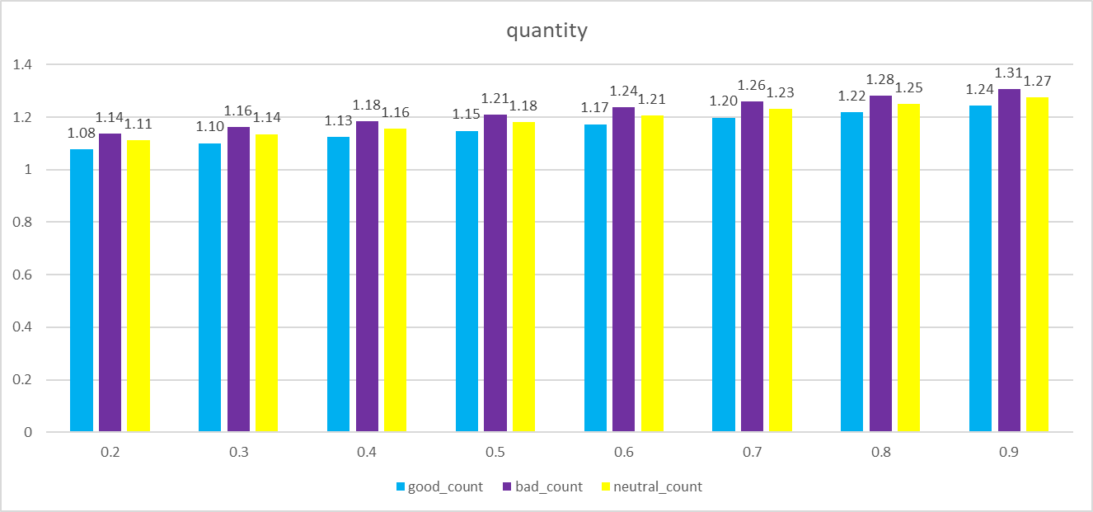

Figure 17

The daily quantity of transactions also increases as the inspection success rate rises. Moreover, the bad guys have the highest quantity of transactions, followed by the neutral people, and finally the good guys.

* + - 1. **Degree of fairness**
      2. **Asset**

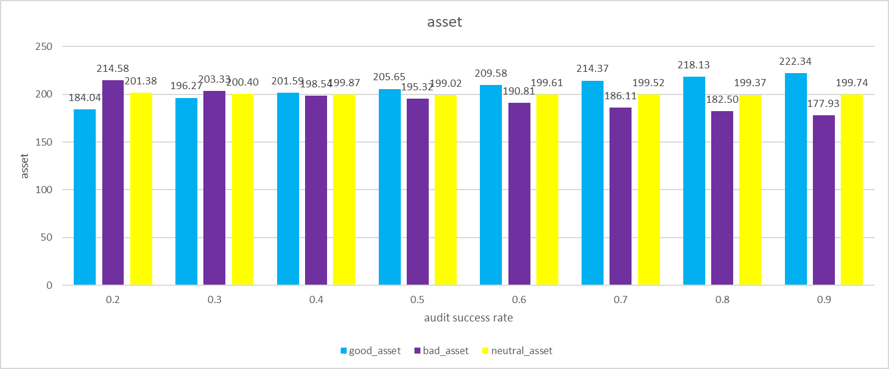

Figure 18

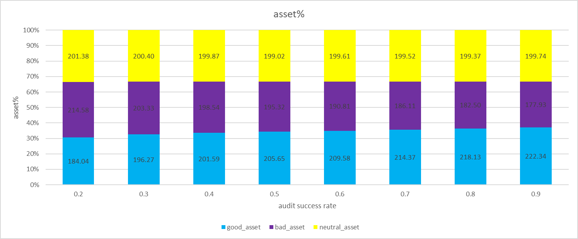

Figure 19

In terms of assets, as the inspection rate increases, the assets of good people continue to rise, while those of bad people keep declining. Neutral people are less affected by the inspection rate. Good people can get better rewards when they comply with tax laws, and social fairness has been improved.

**3.** **Simulation of the Blockchain Electronic Invoice System**

The above simulation is the data statistical results of the paper invoice system under different inspection success rates. However, the cost of the blockchain electronic invoice system cannot be the same as that of the paper invoice. On the contrary, there is a high probability that the cost of the blockchain electronic invoice system is higher than that of the paper invoice. Therefore, for the blockchain electronic invoice, we will make the following assumptions:

I. The cost of the blockchain electronic invoice system is c, while the cost of the paper invoice system is so low compared with the daily revenue of the tax bureau that it can be ignored, that is, it is 0. In the model, we will calculate and simulate the data statistical situations when the cost of the blockchain electronic invoice system is 0.3, 0.6, and 0.9, and make a comparison with the data of the paper invoice.

II. Regarding the tax revenue and fine revenue, the tax bureau will first use them to maintain the system cost c. The maintenance of the system cost is defined in the model as the salary paid to IT personnel, and the daily expenses of these IT personnel are to buy rice and meat in the market. Therefore, the salary of IT personnel will eventually flow back to the farmers and herders. Of course, the actual system cost is definitely not just as simple as the salary of IT personnel. There are also server fees paid to suppliers, patent fees, water and electricity fees, etc. However, the ultimately paid costs will all flow back to the food market because food is a necessity. And in order to simplify the model and make the process clearer, the model assumes that the money spent on road construction and IT by the tax bureau will be evenly distributed back to the farmers and herders.

III. The relationship between the probability of secondary transactions ${prob}^{m}$ and the fiscal expenditure is as follows:

$${prob}^{m}=\frac{r-c}{6}$$

For the paper invoice system, $c=0$。

**3.1.** **Economic benefits**

**3.1.1.Probability of secondary transactions**

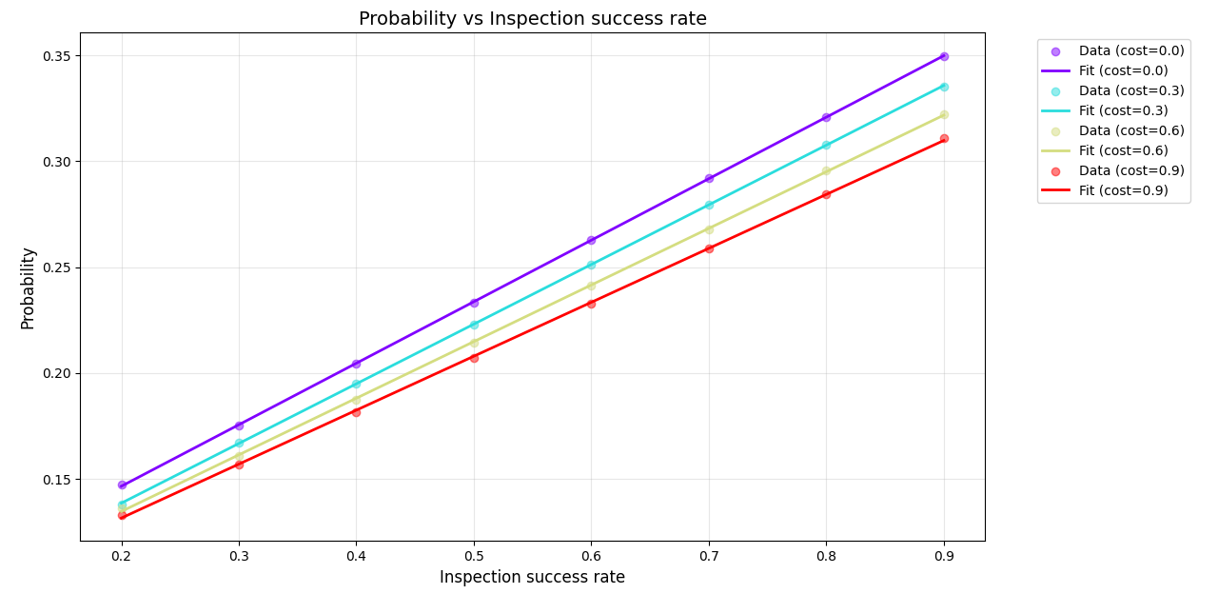

Figure 20

The above figure shows the probability of secondary transactions of invoice systems with different costs under different inspection rates. From the figure, it can be seen that regardless of the cost, the relationship between the inspection rate and the probability of secondary transactions is positively correlated and approaches a straight line. Therefore, it can be assumed that their relationship is a linear function. Through regression fitting, their equation is obtained as:

**When c = 0.0:**

${prob}^{m}$ = 0.088522 + 0.290376 ${prob}_{0.0}^{t}$

*

R² = 0.999962

**When c = 0.3:**

${prob}^{m}$ = 0.082279 + 0.281677 ${prob}_{0.3}^{t}$

*

R² = 0.999975

**When c = 0.6:**

${prob}^{m}$ = 0.081229 + 0.267295 ${prob}_{0.6}^{t}$

*

R² = 0.999859

**When c = 0.9:**

${prob}^{m}$ = 0.080654 + 0.254638 ${prob}_{0.9}^{t}$

*

R² = 0.999814

Whether it is from the graph or the finally fitted function, it can be seen that the slope of the paper invoice system is the highest, while the slope of the blockchain electronic invoice system with c = 0.9 is the lowest. This means that for the paper invoice system, increasing the inspection rate can lead to a higher probability of secondary transactions, that is, the marginal benefit is higher.

**3.1.2.Revenue**

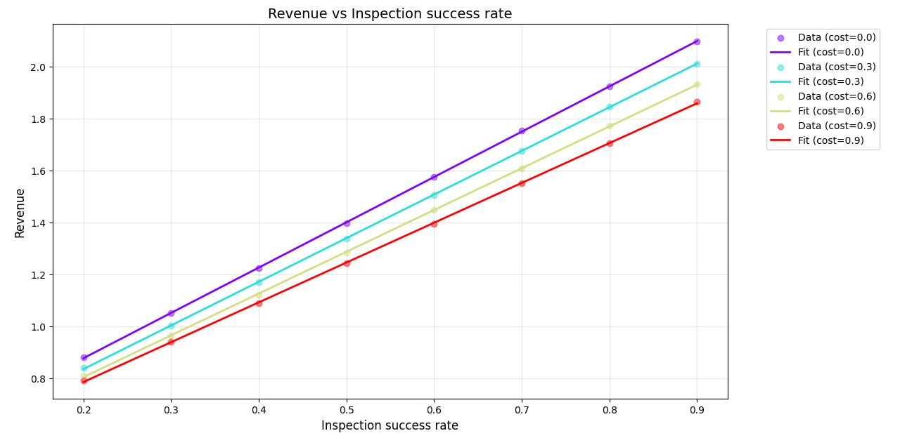

Figure 21

Similarly, by performing a regression of a linear equation for ${prob}_{c}^{t}$ and revenue, we obtain:

**When c = 0.0:**

revenue = 0.529706 + 1.744297 ${prob}_{0.0}^{t}$

*

R² = 0.999

**When c = 0.3:**

revenue = 0.500779 + 1.679909 ${prob}_{0.3}^{t}$

*

R² = 0.999

**When c = 0.6:**

revenue = 0.484021 + 1.608560 ${prob}_{0.6}^{t}$

*

R² = 0.999

**When c = 0.9:**

revenue = 0.480394 + 1.532866 ${prob}_{0.9}^{t}$

*

R² = 0.999

Similar to the probability of secondary transactions, the total revenue of the tax bureau is the highest when the cost of the invoice system c = 0, and the marginal benefit under different inspection rates is also the highest.

Next, let's study under what costs and inspection rates of the blockchain electronic invoice system the tax bureau can obtain more revenue than from the paper invoice system. We can first assume that the revenues are equal when c = 0 and c = 0.3, that is,

0.529706 + 1.744297 ${prob}_{0.0}^{t}$* = 0.500779 + 1.679909 ${prob}_{0.3}^{t}$

*

By solving the equation, we get:

$${prob}_{0.3}^{t}=1.0383{prob}_{0.0}^{t}+0.0289$$

That is to say, when the cost of the blockchain electronic invoice system c = 0.3, the inspection success rate of this system needs to satisfy ${prob}_{0.3}^{t}>1.0383{prob}_{0.0}^{t}+0.0289$ for this new system to bring more revenue to the tax bureau.

Similarly, we can obtain:

$${prob}_{0.6}^{t}=1.0844{prob}_{0.0}^{t}+0.0457$$

$${prob}_{0.9}^{t}=1.1379{prob}_{0.0}^{t}+0.0493$$

That is to say, when the cost of the blockchain electronic invoice system is 0.6, the inspection success rate of the system needs to satisfy ${prob}_{0.6}^{t}>1.0844{prob}_{0.0}^{t}+0.0457$ for the new system to bring more revenue to the tax bureau. When the cost of the blockchain electronic invoice system is 0.9, the inspection success rate of the system needs to satisfy ${prob}_{0.9}^{t}>1.1379{prob}_{0.0}^{t}+0.0493$ for the new system to bring more revenue to the tax bureau.

**3.1.3.Volume**

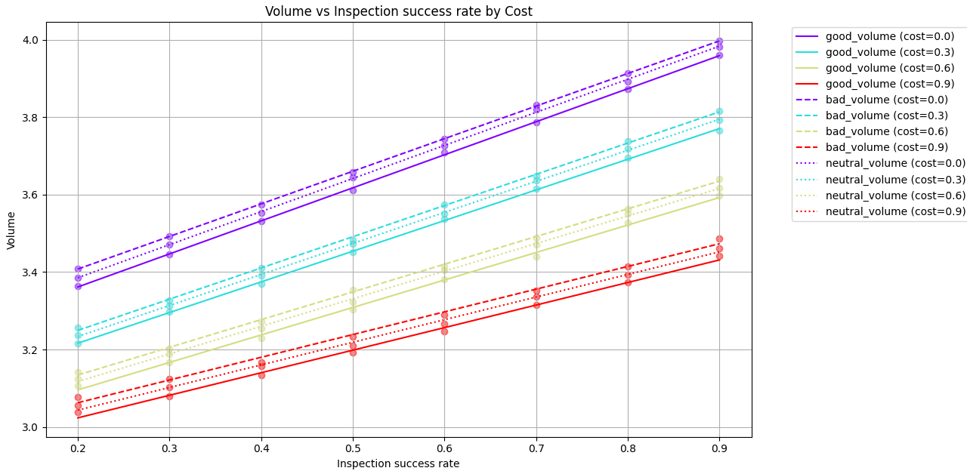

Figure 22

Through the fitting of the regression equation, the following results are obtained:

**good_volume ：**

**When c = 0.0:**

good_volume = 3.191 + 0.853 ${prob}_{0.0}^{t}$

*

R² = 1.000

**When c = 0.3:**

good_volume = 3.058 + 0.792 ${prob}_{0.3}^{t}$

*

R² = 1.000

**When c = 0.6:**

good_volume = 2.954 + 0.710 ${prob}_{0.6}^{t}$

*

R² = 0.998

**When c = 0.9:**

good_volume = 2.907 + 0.582 ${prob}_{0.9}^{t}$

*

R² = 0.996

**bad_volume：**

**When c = 0.0:**

bad_volume = 3.239 + 0.842 ${prob}_{0.0}^{t}$

*

R² = 1.000

**When c = 0.3:**

bad_volume = 3.088 + 0.806 ${prob}_{0.3}^{t}$

*

R² = 0.999

**When c = 0.6:**

bad_volume = 2.991 + 0.715 ${prob}_{0.6}^{t}$

*

R² = 0.999

**When c = 0.9:**

bad_volume = 2.945 + 0.586 ${prob}_{0.9}^{t}$

*

R² = 0.995

**neutral_volume：**

**When c = 0.0:**

neutral_volume = 3.214 + 0.854 ${prob}_{0.0}^{t}$

*

R² = 1.000

**When c = 0.3:**

neutral_volume = 3.073 + 0.801 ${prob}_{0.3}^{t}$

*

R² = 1.000

**When c = 0.6:**

neutral_volume = 2.975 + 0.712 ${prob}_{0.6}^{t}$

*

R² = 0.999

**When c = 0.9:**

neutral_volume = 2.927 + 0.584 ${prob}_{0.9}^{t}$

*

R² = 0.997

For the convenience of analysis, we use the total quantity of transactions to measure the total economic benefits of this economy, and examine what conditions the inspection rate of the blockchain electronic invoice system with different costs needs to meet in order to bring higher economic benefits than the paper invoice system.

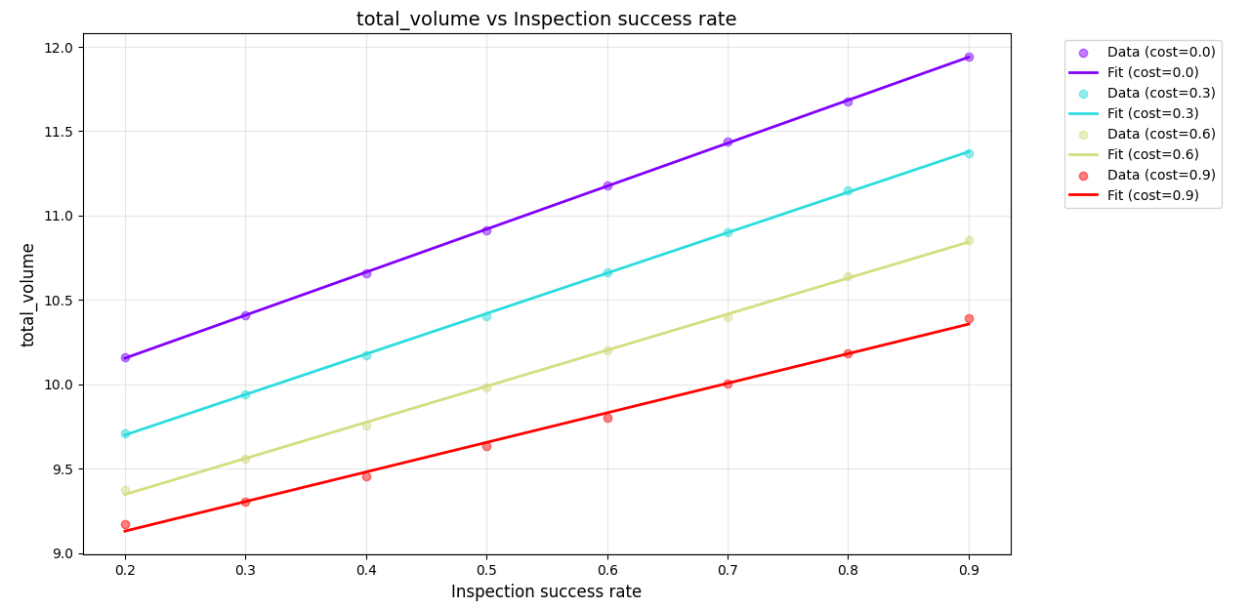

Figure 23

**When c = 0.0:**

volume = 9.644755 + 2.549258 ${prob}_{0.0}^{t}$

*

R² = 0.999

**When c = 0.3:**

volume = 9.219388 + 2.399206 ${prob}_{0.3}^{t}$

*

R² = 0.999

**When c = 0.6:**

volume = 8.919576 + 2.137473 ${prob}_{0.6}^{t}$

*

R² = 0.999

**When c = 0.9:**

volume = 8.779093 + 1.752870 ${prob}_{0.9}^{t}$

*

R² = 0.996

When c = 0.3, assume that:

9.644755 + 2.549258 ${prob}_{0.0}^{t}$* = 9.219388 + 2.399206 ${prob}_{0.3}^{t}$

*

It is solved that:

${prob}_{0.3}^{t}$ =1.0625 ${prob}_{0.0}^{t}$ +0.4254

So when c = 0.3, the inspection success rate needs to be more than 1.0625 times that of the paper invoice system's inspection success rate and also 0.4254 higher in order for the economic benefits to be significantly improved.

Similarly, we can get:

${prob}_{0.6}^{t}$ =1.1927 ${prob}_{0.0}^{t}$ +0.7252

${prob}_{0.9}^{t}$ =1.4544 ${prob}_{0.0}^{t}$ +0.8657

So when c = 0.6, the economic benefits can be significantly improved only when the inspection success rate is more than 1.1927 times that of the paper invoice system's inspection success rate and also 1.0813 higher. When c = 0.9, the economic benefits can be significantly improved only when the inspection success rate is more than 1.1927 times that of the paper invoice system's inspection success rate and also 1.0813 higher.

**3.2.** **Degree of fairness**

**3.2.1.Asset**

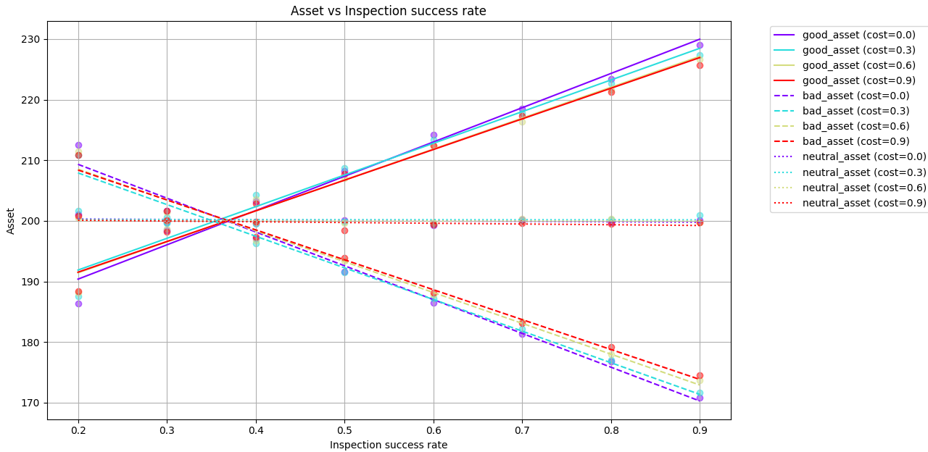

Figure 24

Fit the regression equation for the asset curves of good people and bad people. **good_asset：**

**When c = 0.0:**

good_asset = 179.063 + 56.567 ${prob}_{0.0}^{t}$

*

R² = 0.979

**When c = 0.3:**

good_asset = 181.418 + 52.281 ${prob}_{0.3}^{t}$

*

R² = 0.972

**When c = 0.6:**

good_asset = 181.228 + 51.014 ${prob}_{0.6}^{t}$

*

R² = 0.982

**When c = 0.9:**

good_asset = 181.406 + 50.588 ${prob}_{0.9}^{t}$

*

R² = 0.984

**bad_asset：**

**When c = 0.0:**

bad_asset = 220.480 - 55.788 ${prob}_{0.0}^{t}$

*

R² = 0.986

**When c = 0.3:**

bad_asset = 218.346 - 52.200 ${prob}_{0.3}^{t}$

*

R² = 0.987

**When c = 0.6:**

bad_asset = 218.709 - 50.889 ${prob}_{0.6}^{t}$

*

R² = 0.986

**When c = 0.9:**

bad_asset = 218.257 + -49.362 ${prob}_{0.9}^{t}$

*

R² = 0.989

It can be seen that regardless of the cost, when the inspection rate is greater than 0.4, the assets of good people will be higher than those of bad people and neutral people.

At the same time, it can also be seen that when the inspection rate is relatively small, close to 0.2, the assets of good people under the paper invoice system are lower than those under the blockchain electronic invoice system. When the inspection rate increases and exceeds 0.4, the assets of good people under the paper invoice system are higher than those under the blockchain electronic invoice system. For bad people, when the inspection rate is relatively small, the assets of bad people under the paper invoice system are lower than those under the blockchain invoice system. When the inspection rate is greater than 0.4, the assets of bad people under the paper invoice system are lower than those under the blockchain electronic invoice system. And when it is near 0.4, when the cost c = 0.3, the assets of good people are the highest, that is, the degree of social fairness is the highest.

**Conclusion**

The simulation results in the thesis also provide an answer: compared with the paper invoice system, under certain costs, if the audit rate can be reasonably improved, the blockchain electronic invoice system can enhance both economic efficiency and social equity. This also proves the economic feasibility of implementing such a system.

Additionally, this model can be used not only to compare the economic values of the blockchain electronic invoice system and the paper invoice system but also to simulate other invoicing systems, such as centralized electronic invoicing systems. Many parameters of the model are modifiable, and its code has been open-sourced on GitHub. Therefore, tax authorities in various countries can build secondary models based on this framework and perform simulation predictions using their own data. Researchers can adjust parameters for simulations according to actual conditions—for example, using different functions to model how road maintenance affects transaction volumes, setting commodities as items other than rice and meat, or replacing the exponential function for purchasing desire with any other reasonable function. Further extensions are also possible, such as designing more goods and services based on Maslow's hierarchy of needs, adding more roles and commodity circulation links, and incorporating factors like VAT input tax and income tax. These capabilities are highly valuable for tax authorities, as they can use their private data for simulations to obtain more insightful results, ultimately making market operations more efficient and enhancing social equity.

**Bibliography**

1. Lauré, M. (1954). Le système de taxe sur la valeur ajoutée (TVA). Revue Française de Finances Publiques, 8(2), 145-158.
2. 中国政府网. 2024 年财政收支情况 [EB/OL]. 2025-01-24 [2025-05-30].
3. [经济日报：深圳开出区块链电子发票近千万张](https://shenzhen.chinatax.gov.cn/sztax/zdgkml/xwfb/mtbd/201911/0cf9e920d4fe40afb11e95d20f04dee2.shtml)
4. 魏庆福. 增值税防伪税控系统及其安全性设计[J]. 中国工程科学,2000,2(11):84-87. DOI:10.3969/j.issn.1009-1742.2000.11.013.
5. [增值税防伪税控系统的原理是什么_税务网校-正保会计网校](https://www.chinaacc.com/new/253/257/283/2006/1/ad78982273517160023146.htm)
6. Nakamoto, S. (2008). Bitcoin: A Peer-to-Peer Electronic Cash System. Retrieved from <https://bitcoin.org/bitcoin.pdf>
7. Gupta, M. Blockchain for Dummies, IBM Limited ed.; John Wiley & Sons, Inc.: Hoboken, NJ, USA, 2017.
8. Bambara, J.J.; Allen, P.R. Blockchain: A Practical Guide to Developing Business, Law, and Technology Solutions; McGraw-Hill Education: New York, NY, USA, 2018.
9. Laurence, T. Blockchain for Dummies; John Wiley & Sons, Inc.: Hoboken, NJ, USA, 2017.
10. Schenk, A. Value Added Tax a Model Statute and Commentary; American Bar Association: Chicago,IL,USA,1989.
11. Janssen, M.; Weerakkody, V.; Ismagilova, E.; Sivarajah, U.; Irani, Z. A framework for analysing blockchain technology adoption: Integrating institutional, market and technical factors. Int. J. Inf. Manag. 2019, 50, 302–309. [CrossRef]
12. 杜莉,郑毓文.应用区块链技术推动我国增值税征管创新:机制分析和方案设计[J].税务研究,2018,0(6):72-79
13. Milla Sepliana Setyowati, Niken sila De Utami, Arfah Habib Saragih, Adang Hendrawan,Blockchain Technology Application for Value-Added Tax Systems,Journal of Open Innovation: Technology, Market, and Complexity,Volume 6, Issue 4,2020,156,ISSN 2199-8531,https://doi.org/10.3390/joitmc6040156.
14. [深圳商报：您被“区块链电子发票”改变了吗？](https://shenzhen.chinatax.gov.cn/sztax/xwdt/mtsd/201908/fc601d7dbd4649419d37d3e400f5b3b8.shtml)
15. Ahmad Alkhodre, Toqeer Ali, Salman Jan, Yazed Alsaawy, Shah Khusro and Muhammad Yasar, “A Blockchain-based Value Added Tax (VAT) System: Saudi Arabia as a Use-Case” International Journal of Advanced Computer Science and Applications(IJACSA), 10(5), 2019. [http://dx.doi.org/10.14569/IJACSA.2019.0100588](https://dx.doi.org/10.14569/IJACSA.2019.0100588)
16. Bui, Thong & Tan, Le & Nguyen, Tri-Hai & Trawinski, Bogdan & Nguyen, Huy-Tien & Le, Tung. (2022). Blockchain-Based Decentralized Digital Content Management and Sharing System. 10.1007/978-3-031-21967-2_49.
17. Bhat, S., Mehta, P., Marathe, M. (2023). Blockchain-Based System for Storing Warranty Receipts. In: Ranganathan, G., Fernando, X., Rocha, Á. (eds) Inventive Communication and Computational Technologies. Lecture Notes in Networks and Systems, vol 383. Springer, Singapore. https://doi.org/10.1007/978-981-19-4960-9_27
18. Cheng, KW., Heng, SH. (2021). Blockchain-Based Content Sharing and Data Repository System. In: Anbar, M., Abdullah, N., Manickam, S. (eds) Advances in Cyber Security. ACeS 2020. Communications in Computer and Information Science, vol 1347. Springer, Singapore. <https://doi.org/10.1007/978-981-33-6835-4_14>
19. <https://github.com/rigelrozanski/trackomatron.git>
20. https://github.com/sriram-kakarala/ChaInVoice.git
21. Soohyun Cho, Kyungha (Kari) Lee, Arion Cheong, Won Gyun No & Miklos A. Vasarhelyi (2021) Chain of Values: Examining the Economic Impacts of Blockchain on the Value-Added Tax System, Journal of Management Information Systems, 38:2, 288-313, DOI: 10.1080/07421222.2021.1912912
22. K. Narayanam et al., "Blockchain Based e-Invoicing Platform for Global Trade," 2020 IEEE International Conference on Blockchain (Blockchain), Rhodes, Greece, 2020, pp. 385-392, doi: 10.1109/Blockchain50366.2020.00056.
23. [The Case for a Robust Attack on the Tax Gap | U.S. Department of the Treasury](https://home.treasury.gov/news/featured-stories/the-case-for-a-robust-attack-on-the-tax-gap)
24. Internal Revenue Service Research, Applied Analytics & Statistics Tax Gap Projections for Tax Year 2022 Publication 5869 (Rev. 10-2024) Washington, DC October 2024
25. [VAT Gap: EU countries lost €134 billion in VAT revenues in 2019 - European Commission](https://taxation-customs.ec.europa.eu/news/vat-gap-eu-countries-lost-eu134-billion-vat-revenues-2019-2021-12-02_en)
26. Ramsey, F. P. (1928). A mathematical theory of saving. *Economic Journal*, *38*(152), 543–559
27. Tjalling C. Koopmans (1963)，“On the Concept of Optimal Economic Growth” (Cowles Discussion Paper No. 163)
28. Lionel W. McKenzie (1976)，“Turnpike Theory”，《Econometrica》44(5): 841–865
29. Kydland, F. E., & Prescott, E. C. (1982). *Time to Build and Aggregate Fluctuations*. Econometrica, 50(6), 1345–1370.
30. Clarida, R., Gali, J., & Gertler, M. (1999). *The Science of Monetary Policy: A New Keynesian Perspective*. Journal of Economic Literature, 37(4), 1661–1707.
31. Epstein, J.M., & Axtell, R. (1996). *Growing Artificial Societies: Social Science From the Bottom Up*. Brookings Institution Press / MIT Press.
32. Tesfatsion, L. (2001). Introduction to the special issue on agent-based computational economics. *Journal of Economic Dynamics & Control*, 25(3–4), 281–293.
33. Fisher, I. (1911). *The Purchasing Power of Money: Its Determination and Relation to Credit, Interest, and Crises*. Macmillan

**Appendices**

One time simulation_en.py: This is the code for a single simulation with an animation. The parameters inside include initial assets, cost, inspection rate, tax rate, etc. You can modify the corresponding parameters to simulate different scenarios.

3000 time simulation_en.py: This is the code for conducting 3000 simulations and taking the average. The final output documents of this code include an Excel file and a PNG image, which record the data changes within 200 days, including farmers' assets, transaction volume, tax bureau's revenue, probability of secondary transactions, etc.

Modify_en.py: This is the code used to adjust the arrangement order of the exported Excel. It moves "meat" to the first column and "rice" to the second column. The purpose is to make the header order of the Excel files generated under different costs and inspection rates consistent.

Data and chart.xlsx: This is an Excel file used to generate line charts and bar charts for the paper invoice system.

Compare.xlsx: This is the code used to compare the paper invoice system and the blockchain electronic invoice system.

Regression_prob.py, regression_volume.py, etc.: These are used to obtain the regression equations and statistical graphs for various types of data.